圈叉遊戲

Noughts & Crosses

在這個專案，你要創造一個會從遊戲過程中學習的Scratch圈叉(Noughts & Crosses)遊戲

In this project you will create a noughts and crosses game in Scratch that is able to learn from how you play.

你不會告訴電腦要如何玩、也不會告訴它遊戲規則與目標

You won’t give it instructions for how to play, or tell it what the objective or rules of the game are.

你實際上給電腦的是你玩遊戲的過程。當蒐集夠多範例時，電腦就會真正能夠把這遊戲玩上手了，當你跟它玩遊戲時而它把你打敗時你就知道它成功學起來了。

Instead, you’ll show it examples of you playing the game. When it’s seen enough examples to start trying to play for itself, you’ll tell it when it beats you.

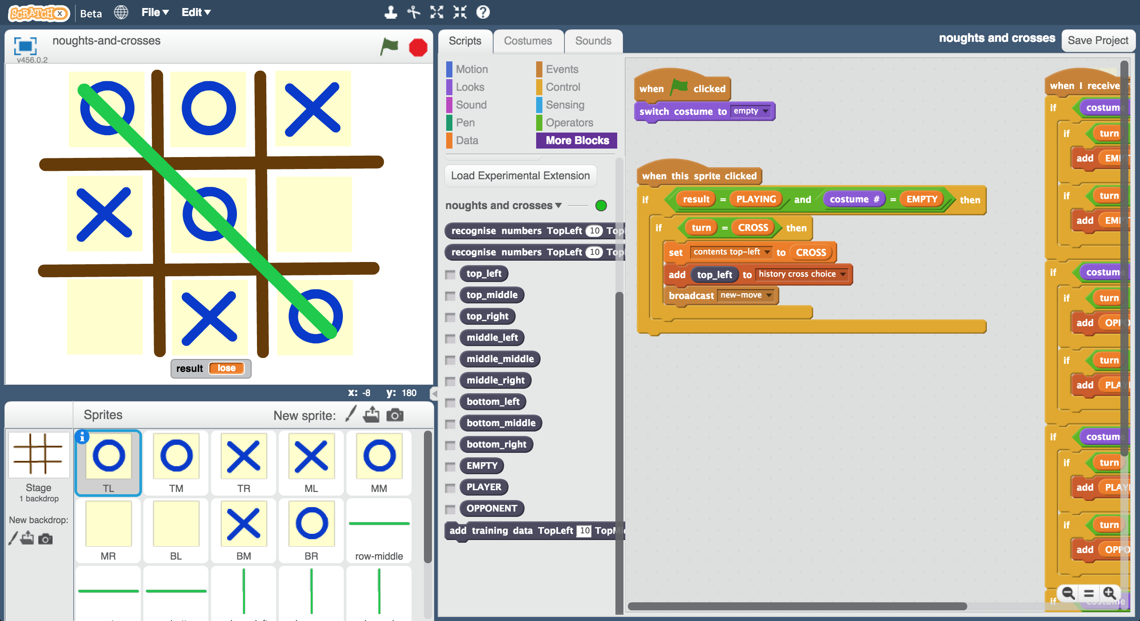

This project worksheet is licensed under a Creative Commons Attribution Non-Commercial Share-Alike License

http://creativecommons.org/licenses/by-nc-sa/4.0/

1. 搜尋網頁：<https://machinelearningforkids.co.uk/scratchx>

Go to <https://machinelearningforkids.co.uk/scratchx> in a browser.

1. 開啟Noughts and Crosses專案

*點選****Project templates*** *->* ***Noughts and Crosses***

Open the Noughts and Crosses project template   
*Click* ***Project templates*** *->* ***Noughts and Crosses***  
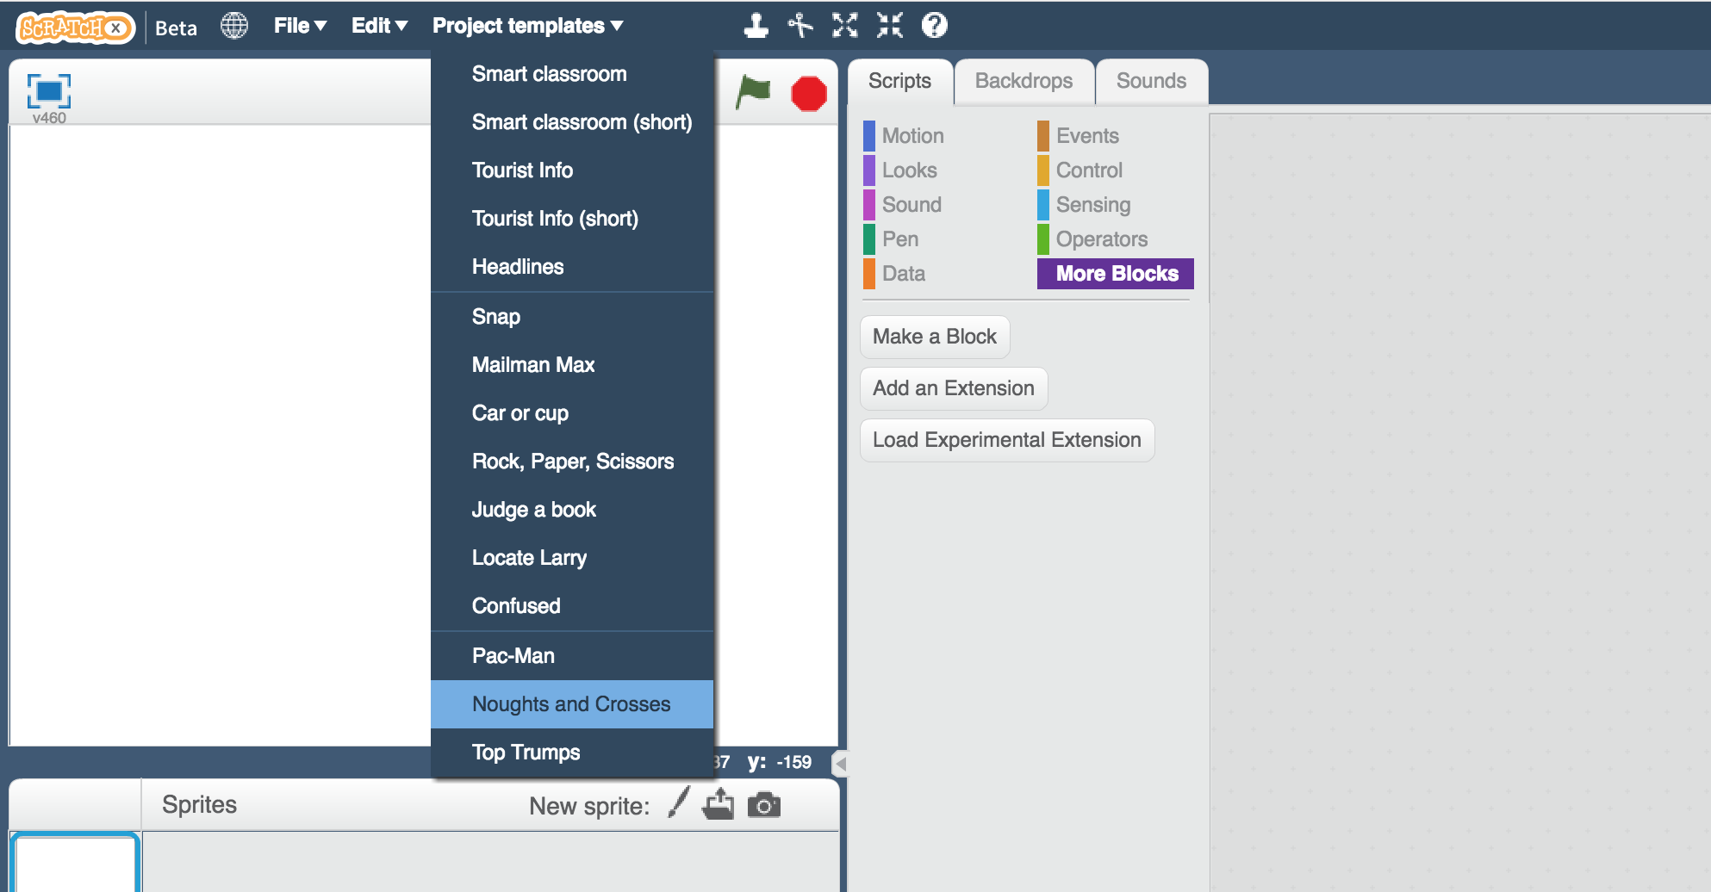

1. 點選全螢幕，再點擊綠旗

Click the **full-screen** button, and then click the Green Flag  
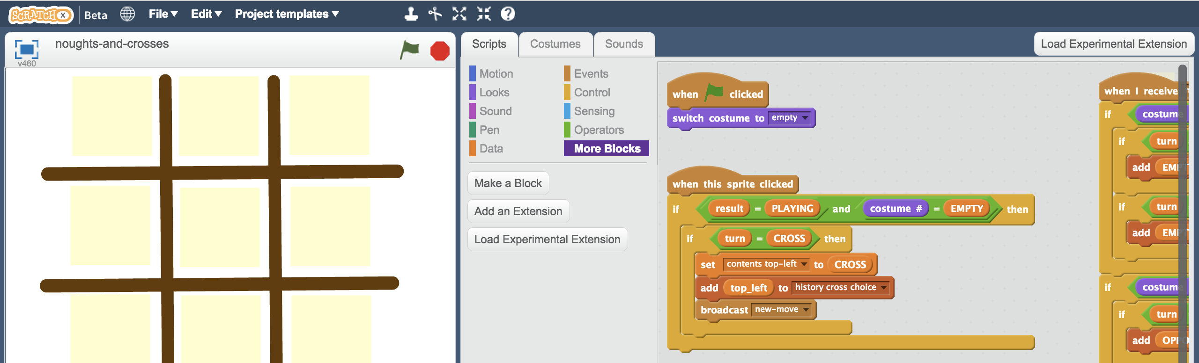

1. 玩一下這個遊戲

*你是叉叉(X)的角色，電腦是圈圈(O)的角色*

*點擊綠旗重新開始遊戲，然後點一下遊戲板*

Play a few games of noughts and crosses  
*You are CROSS (X), the computer is playing as NOUGHTS (O).*   
*Click the green flag to start a new game, then click on the game board.*

1. 你看得出來電腦是如何決定下在哪個位置的嗎？

*如果你有想法了，看看舞台區中****Computer move****區域的程式積木，是不是和你想的一樣？*

Can you see how the computer is choosing where to put its moves?   
*When you’ve worked it out, look at the* ***Computer move*** *block in the* ***Stage***  *Were you right?*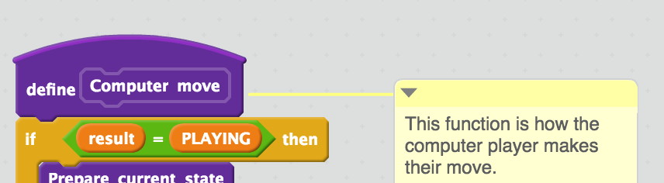

Scratch實作圈叉遊戲

Representing noughts and crosses in Scratch

每個位置都有一個編號，分別是1～9號，

方便寫程式時參照。

The positions of spaces on the noughts and crosses board are numbered from 1 to 9.

Data constants are used to make it easier to refer to them in scripts.

1

2

3

4

5

6

7

8

9

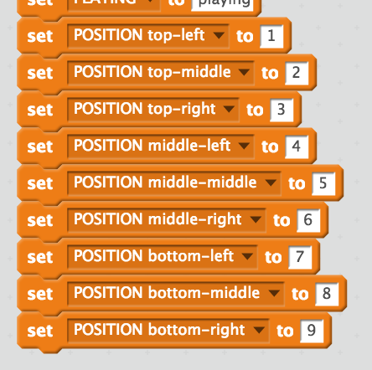

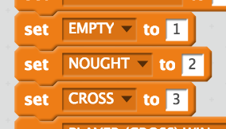

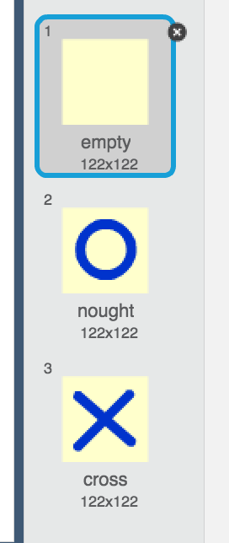

空白的位置以造型1來表示，造型2為O，造型3為X。

An empty space is shown in costume 1.

A nought O is shown in costume 2.

A cross X is shown in costume 3.

Data constants are used to make it easier to refer to these in scripts.

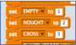

Empty = 1

O = 2

X = 3

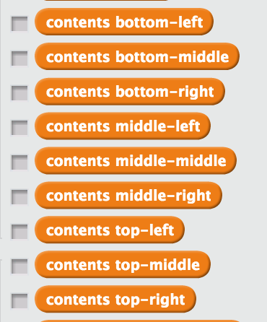

這些變數用來儲存當前遊戲狀態。

舉例來說：目前（如左圖）

contents top-left = 2

contents middle-middle = 3

contents bottom-right = 1

Variables are used to store the current state of the game.

For example, at this point:

contents top-left = 2

contents middle-middle = 3

contents bottom-right = 1

O

X

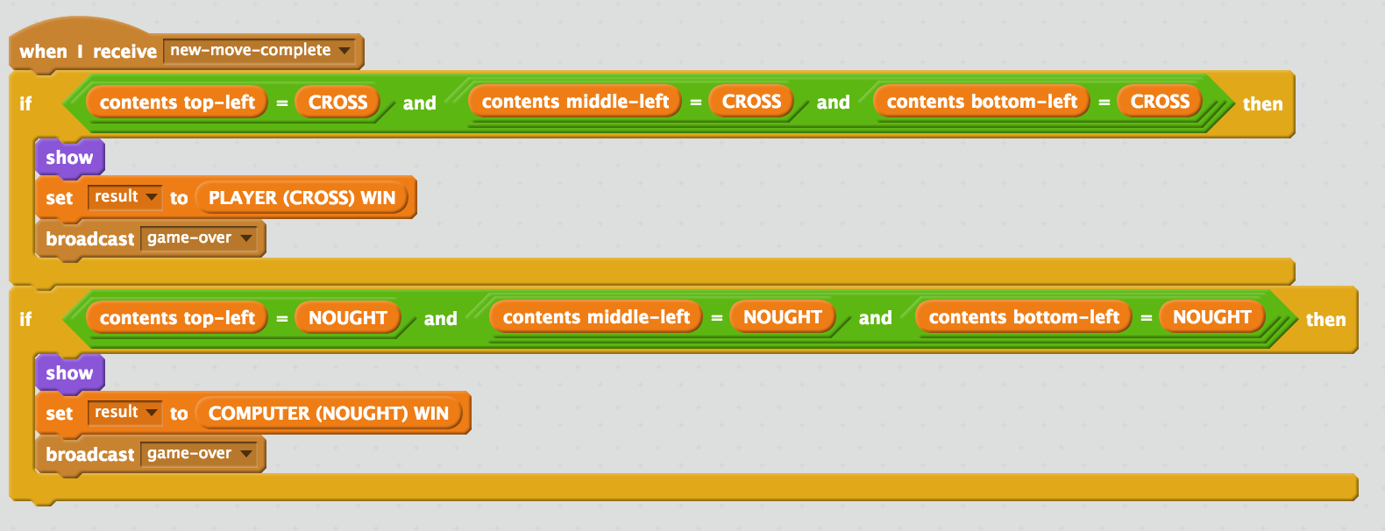

綠色列中的積木用來檢查哪方獲勝。當每輪結束後都會執行這個動作。

Each of the green row and column sprites check to see if someone has won.

This happens after every move.

**接下來要做什麼？**

**What are you going to do?**

你要給電腦一些遊戲過程範例，訓練電腦玩圈叉遊戲

You’re going to train a computer to play noughts and crosses. You’ll do this by showing it examples of how you play the game.

假設這是目前狀態，接下來是O方動作

Imagine the board looks like this and it’s O’s turn.

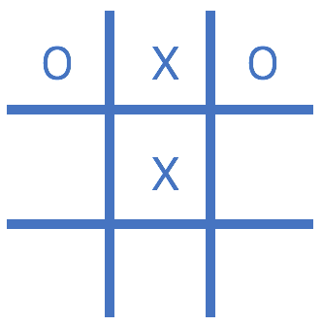

假設你決定把X放在中間下方的位置

Imagine you decide to put your O in

the bottom middle space.

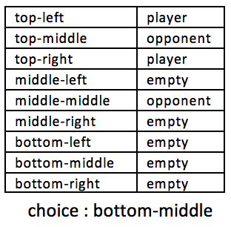

假設這是目前狀態，接下來是X方動作

Imagine the board looks like this and it’s X’s turn.

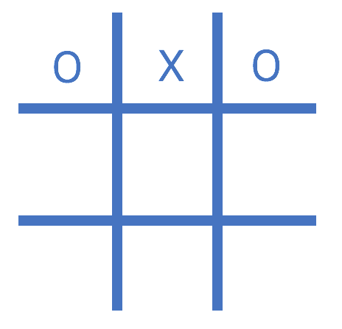

假設你決定把X放在正中的位置

Imagine you decide to put your X in

the centre space.

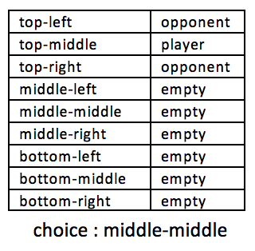

用對手(opponent)和玩家(player)取代圈圈(nought)和叉叉(cross)可以讓電腦學習到兩方的動作

Using “opponent” and “player” instead of “nought” and “cross” means the computer can learn from both nought and cross moves.

你將使用獲得勝利的玩家範例來訓練電腦。

You’ll use examples of moves from the player that wins the game to train the computer.

如果你(X)贏了，就用你下的棋當作範例來訓練電腦，如果電腦(O)贏了，就用電腦下的棋當作範例

If you (X) win, you’ll use your moves as examples to train the computer.

If the computer (O) wins, you’ll use the computer’s moves to train with.

這些**獲勝的範例**會教電腦怎麼贏這個遊戲！

These **examples of moves that lead to winning** will teach the computer how to play to win!

1. 關閉Scratch視窗，搜尋網頁https://machinelearningforkids.co.uk

Close Scratch window then go to https://machinelearningforkids.co.uk

1. 點選“**Get started**”按鈕

Click on “**Get started**”

1. 點選“**Log In**”按鈕並登入系統

*如果你沒有帳號，請你的老師幫你建立一個帳號。*

*如果你不記得你的帳號或密碼，請你的老師幫你重新設定一次。*

Click on “**Log In**” and type in your username and password  
*If you don’t have a username, ask your teacher to create one for you.  
If you can’t remember your password, ask your teacher to reset it for you.*

1. 點選上方清單中的 **”Projects”** 按鈕

Click on “**Projects**” on the top menu bar

1. 點選 “**+ Add a new project**” 按鈕

Click on the **“+ Add a new project**” button.

1. 將你的專案命名為 “noughts and crosses”並設定成辨識 “**numbers**”類別

Name your project “noughts and crosses” and set it to learn how to recognise “**numbers**”

1. 點選“**Add a value**”按鈕

Click “**Add a value**”  
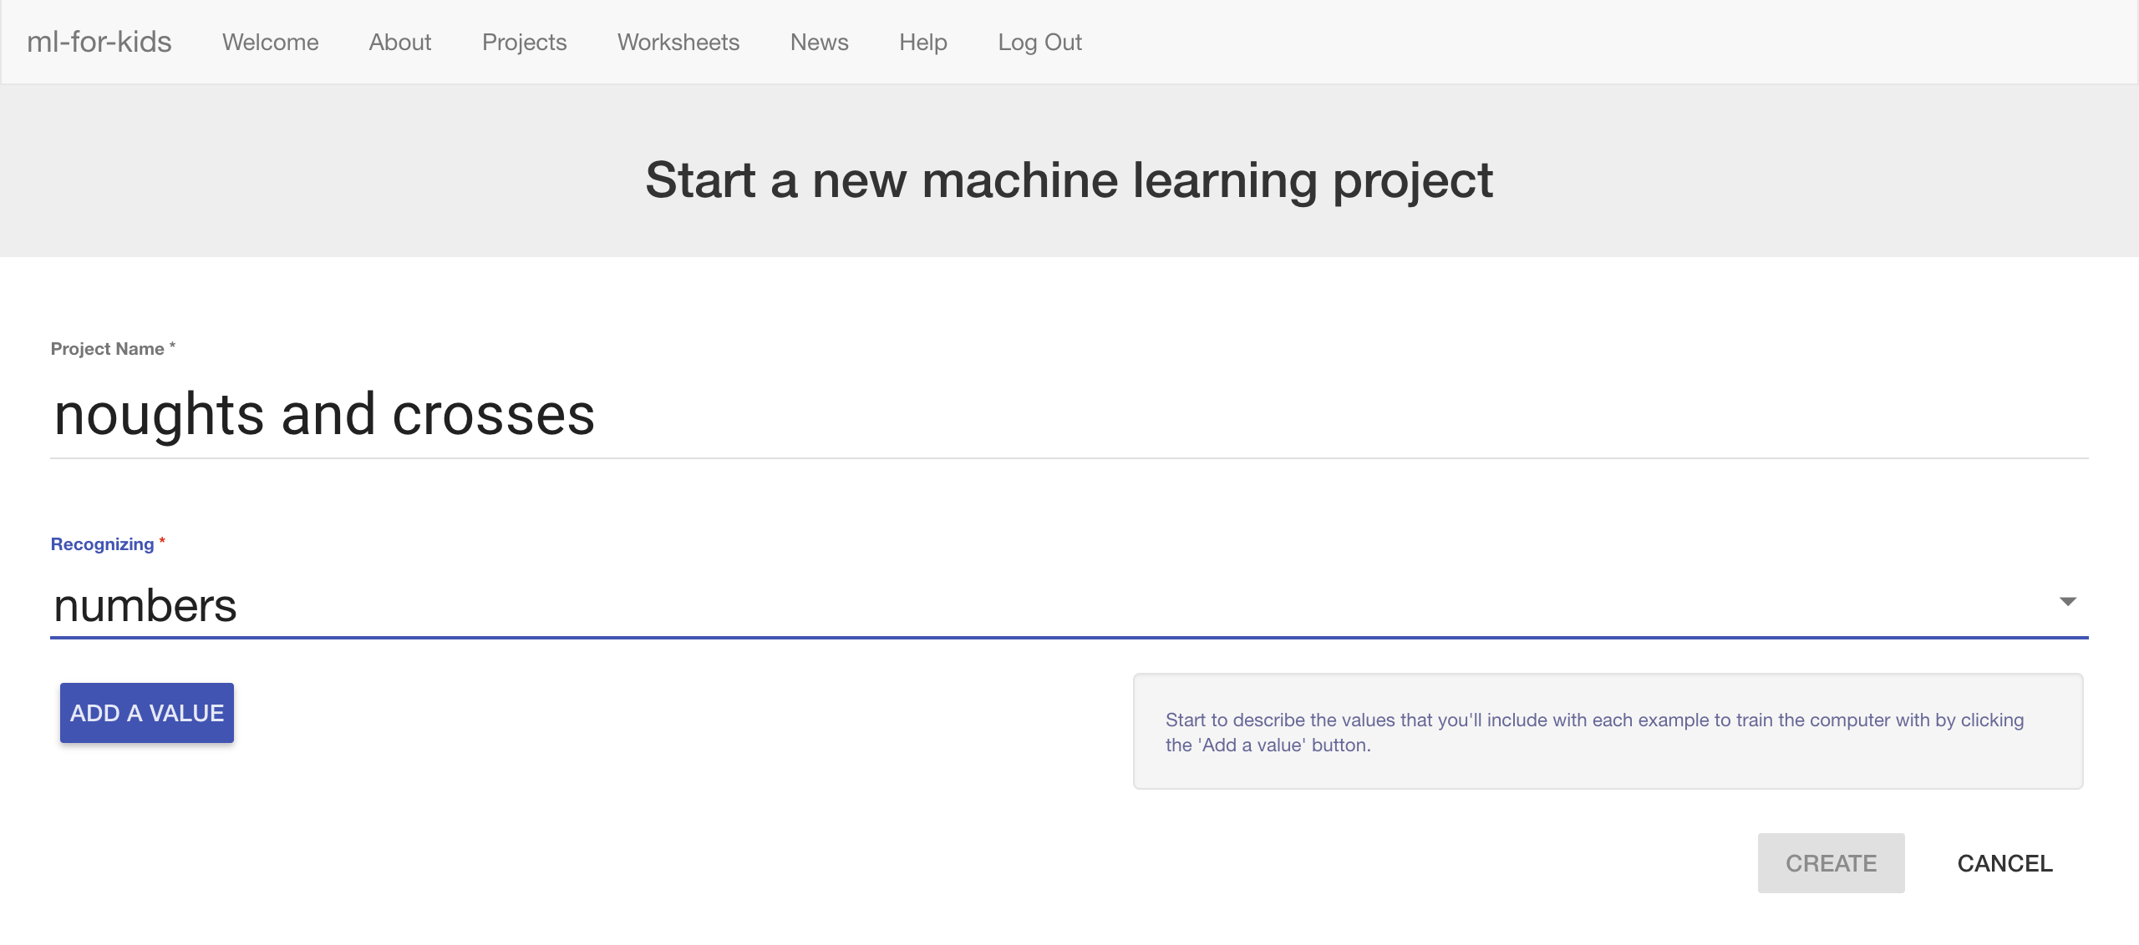

1. 命名為“**TopLeft**”，類別選擇 “**multiple-choice**”

Name a value “**TopLeft**” and make it “**multiple-choice**”  
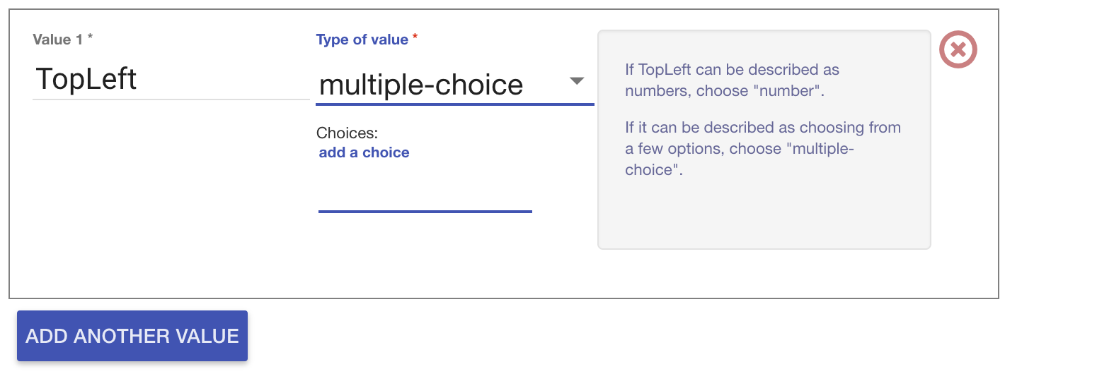

1. 在**add a choice**區域輸入EMPTY，按下enter鍵，再如法炮製，輸入PLAYER和OPPONENT（如下圖）

*這些是圈叉遊戲左上方方格可能出現的內容，可能是空白、玩家（圈圈）或對手（叉叉）*

Type “EMPTY” into the “**add a choice**” box and press Enter  
Type “PLAYER” into the “**add a choice**” box and press Enter  
Type “OPPONENT” into the “**add a choice**” box and press Enter  
*These are the possible contents for the top-left space in the noughts and crosses board. It can be empty, or it can have the player’s own shape (cross) in it, or it can have the opponent’s shape in it (nought).*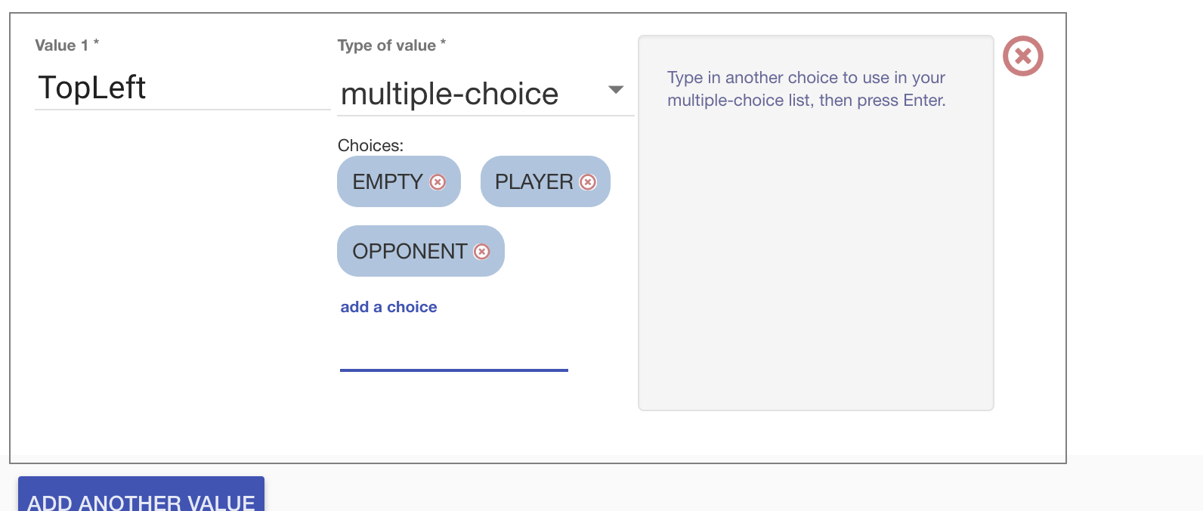

1. 點選“**Add another value**”

Click “**Add another value**”

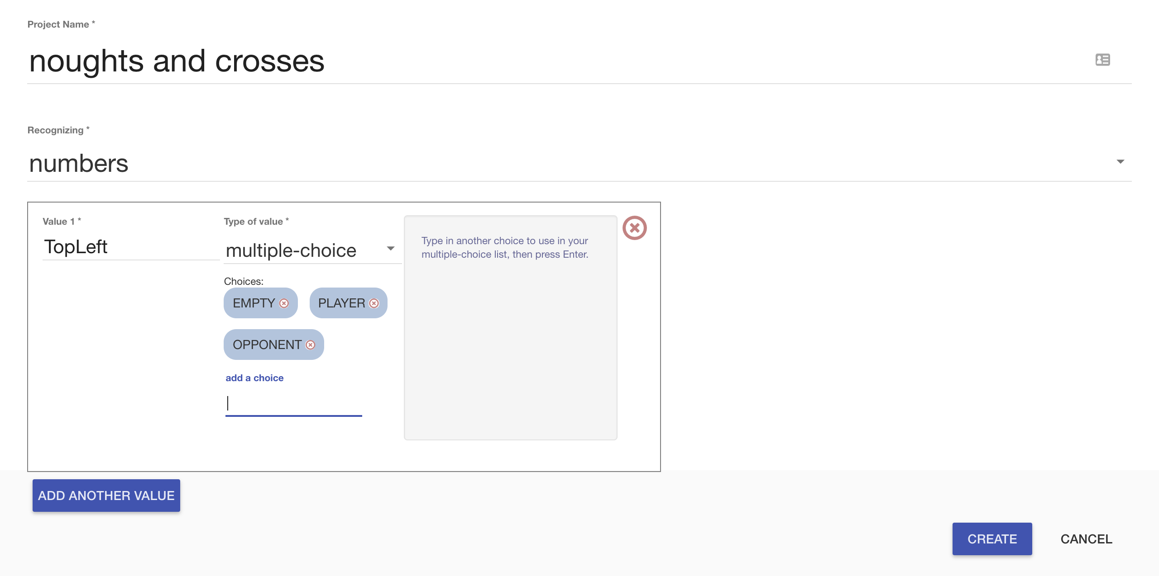

1. 命名為“**TopMiddle**”，類別選擇 “**multiple-choice**”

Call the next value “**TopMiddle**” and make it “**multiple-choice**”   
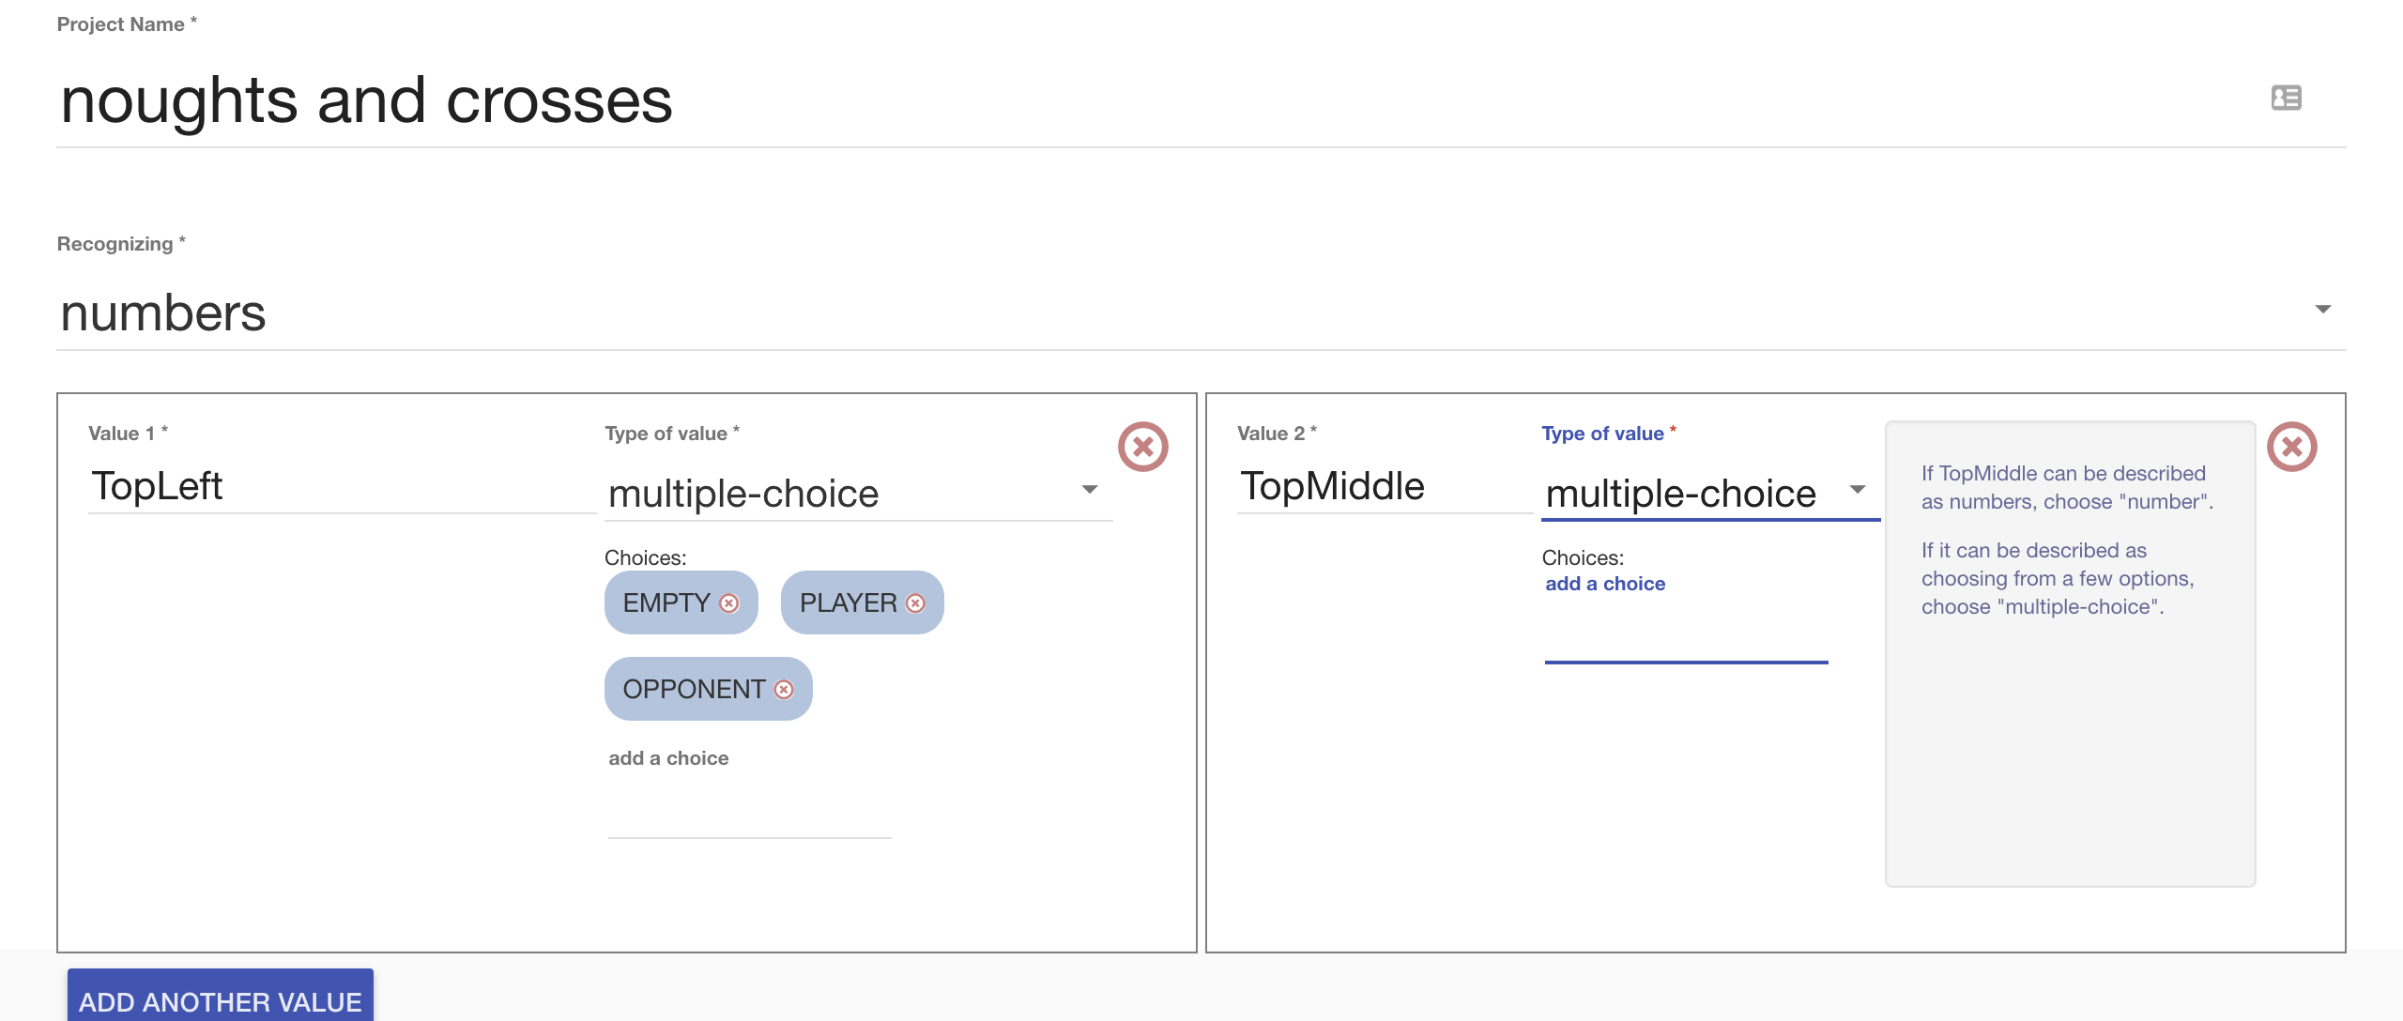

1. 為加入三個選項：EMPTY、PLAYER和OPPONENT，如同剛剛的TopLeft一樣

Add “EMPTY”, “PLAYER”, and “OPPONENT” to “TopMiddle”   
as you did to “TopLeft”

1. 重複動作，新增遊戲板上的其他位置（如下方清單），並一一加入EMPTY、PLAYER和OPPONENT三個選項

*TopLeft, TopMiddle, TopRight,   
MiddleLeft, MiddleMiddle, MiddleRight,   
BottomLeft, BottomMiddle, BottomRight*

記得，”EMPTY”、”PLAYER”、”OPPONENT”一定要在這九個位置都用一樣的拼法（包含大小寫），**這非常重要！**

Repeat for the other positions on a noughts-and-crosses board  
*Each example is the state of the board before a move that led to a win. TopLeft, TopMiddle, TopRight,   
MiddleLeft, MiddleMiddle, MiddleRight,   
BottomLeft, BottomMiddle, BottomRight  
  
It’s* ***very important*** *that you spell “EMPTY”, “PLAYER” and “OPPONENT” in the same way for all nine positions.*

1. 點選“**Create**”

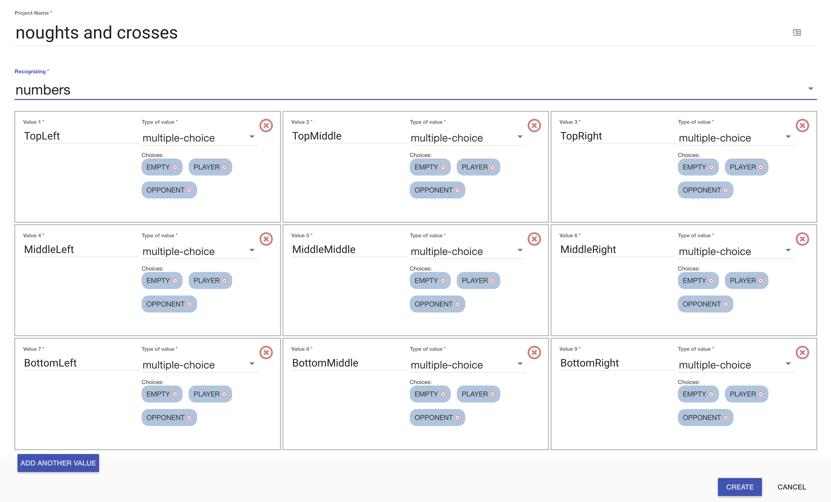 Click “**Create**”

1. 你會在專案清單中看到“**noughts and crosses**”，點選此專案

You should see “**noughts and crosses**” in your list of projects.   
Click on it.

1. 點選 **”Train”** 按鈕

Click the “**Train**” button  
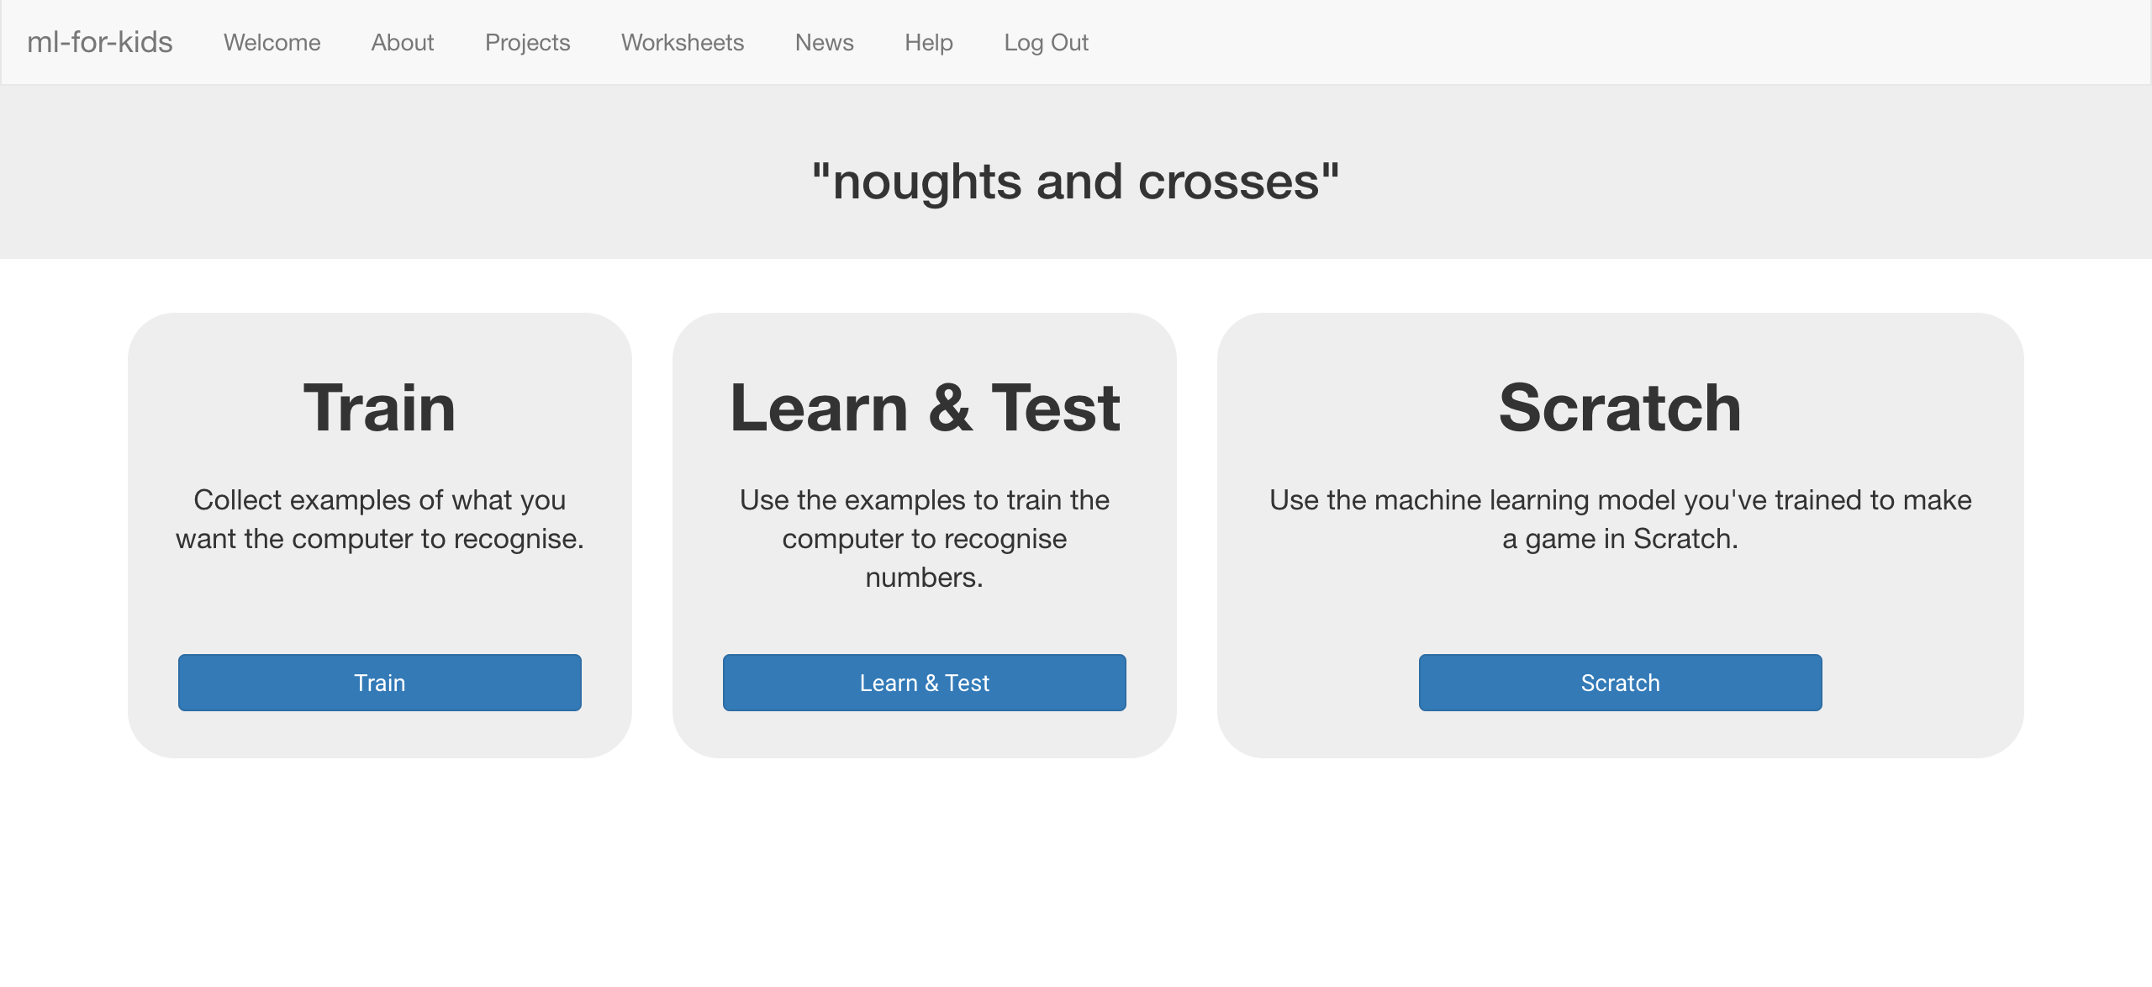

1. 點選**+ Add new label**按鈕，將標籤命名為：top left

*獲勝範例中如果有左上方格子的動作會被紀錄在這個方框裡*

Click “**+ Add new label**” and create a label called “top left”  
*Examples of making a move in the top-left box (in games that lead to a win) will go in this bucket.*   
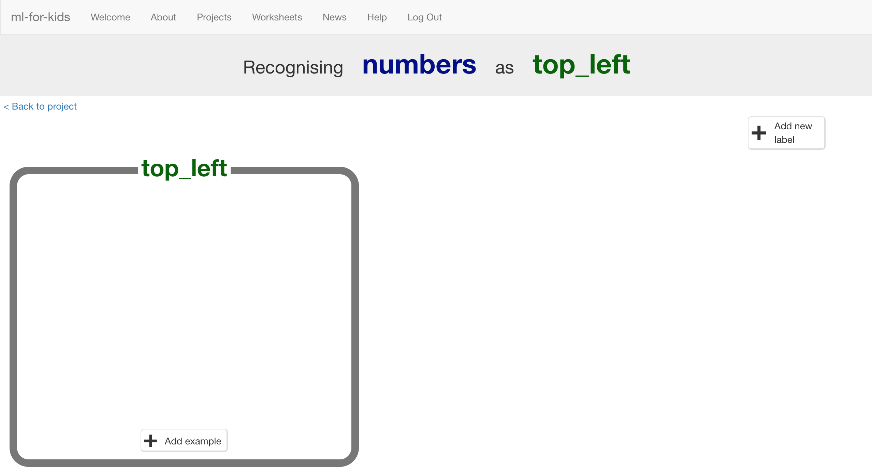

1. 點選**+ Add new label**按鈕，新增其他八個位置：*“top middle”, “top right”, “middle left”, “middle middle”, “middle right”, “bottom left”, “bottom middle”, “bottom right” （如下圖）*

Click “**+ Add new label**” again and create labels for the other eight spaces on the board.  
*“top middle”, “top right”,   
“middle left”, “middle middle”, “middle right”,   
“bottom left”, “bottom middle”, “bottom right”  
  
(see the next page for a picture)*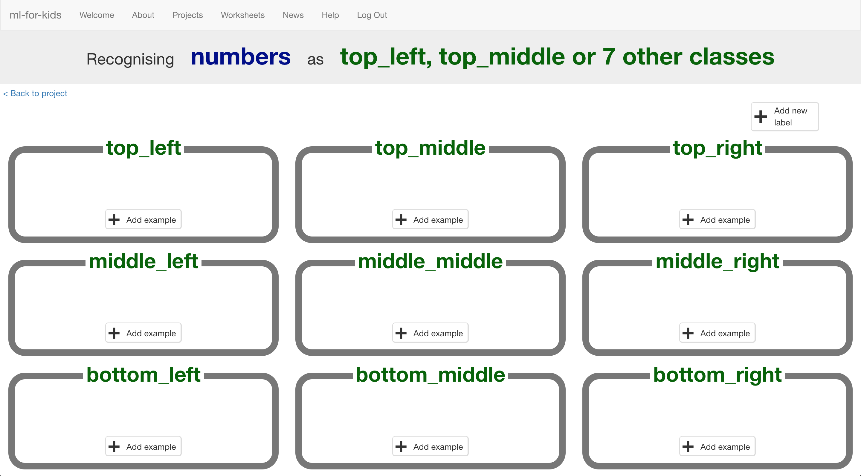

1. 點選“**< Back to project**”， 選擇**Scratch**

Click the “**< Back to project**” link then click **Scratch**

1. 點選**Open in Scratch**按鈕

Click the **Open in Scratch** button  
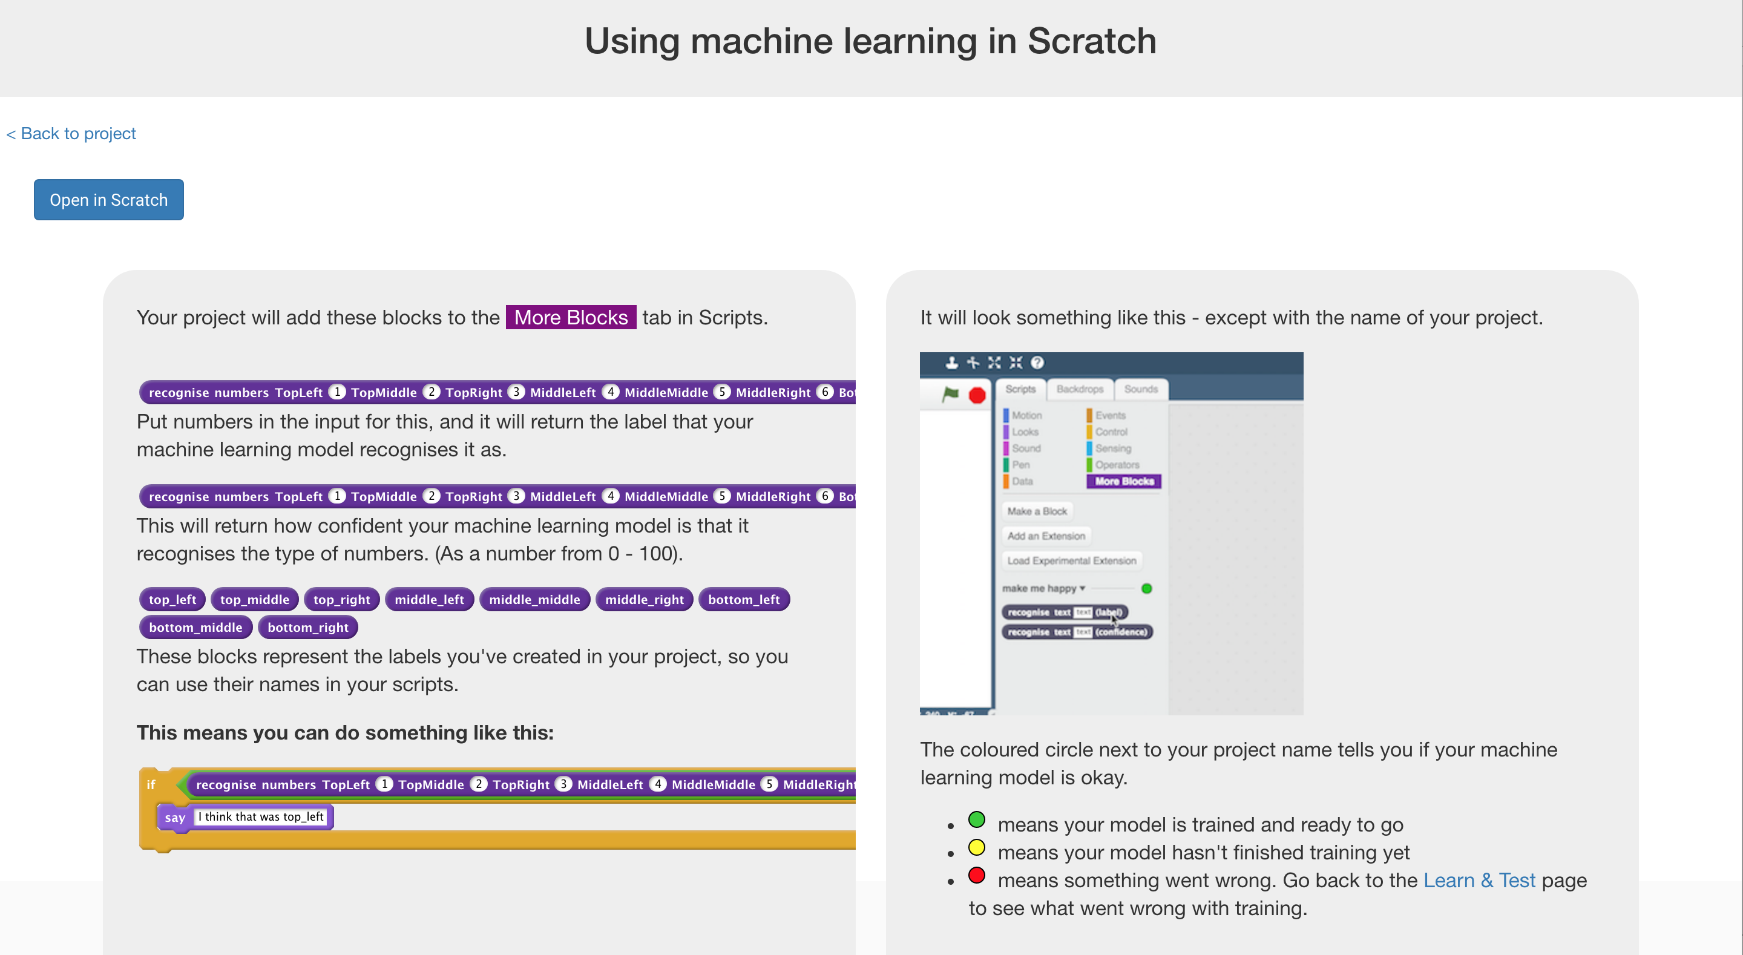

1. 這時會出現一個警告，提醒你還沒有訓練電腦，但這沒關係，因為我們要用Scratch來搜集訓練用的範例。

點選**Straight into Scratch**按鈕

You’ll get a warning that you haven’t trained the computer yet  
*That’s okay – you’ll use Scratch to collect training examples.   
Click the go “****straight into Scratch****” now button.   
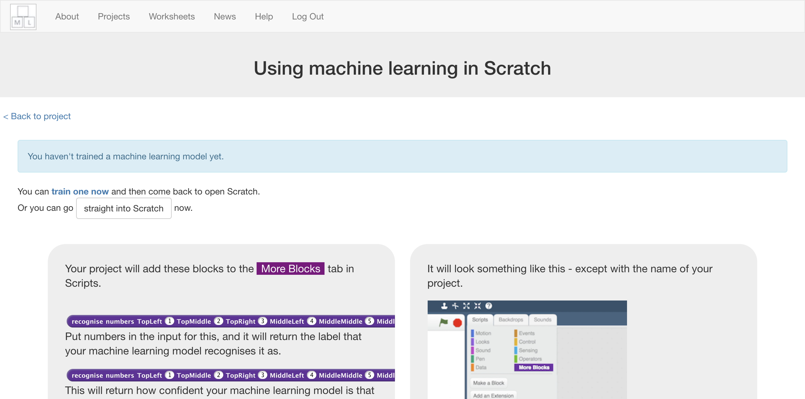*

1. 你可以在專案裡的『更多積木』(More blocks)區看到新積木

You should see new blocks in the “**More blocks**” section from your “noughts and crosses” project.  
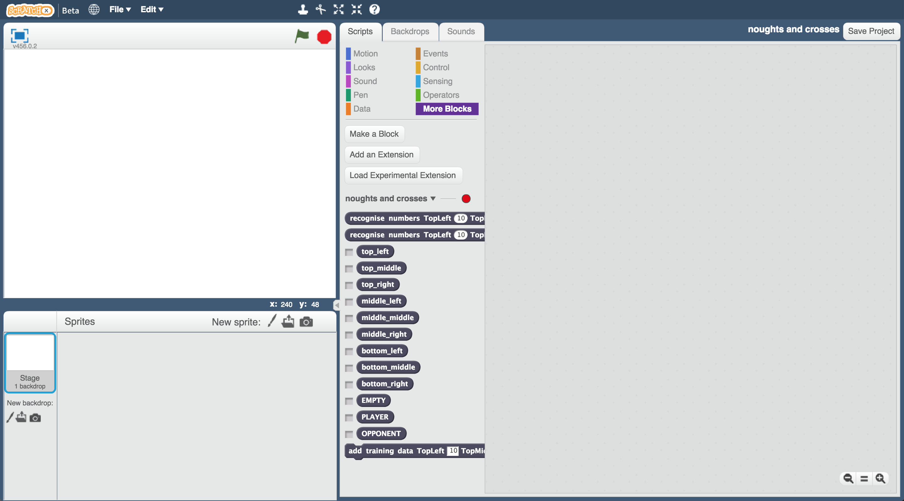

1. 再次開啟Noughts and Crosses專案

*點選****Project templates*** *->* ***Noughts and Crosses***

Open the Noughts and Crosses project template again.  
*Click* ***Project templates*** *->* ***Noughts and Crosses***

1. 點選『舞台』，在程式碼中尋找以“**setup model labels**”為開頭的積木，

Click on the “**Stage**” and find the “**setup model labels**” script  
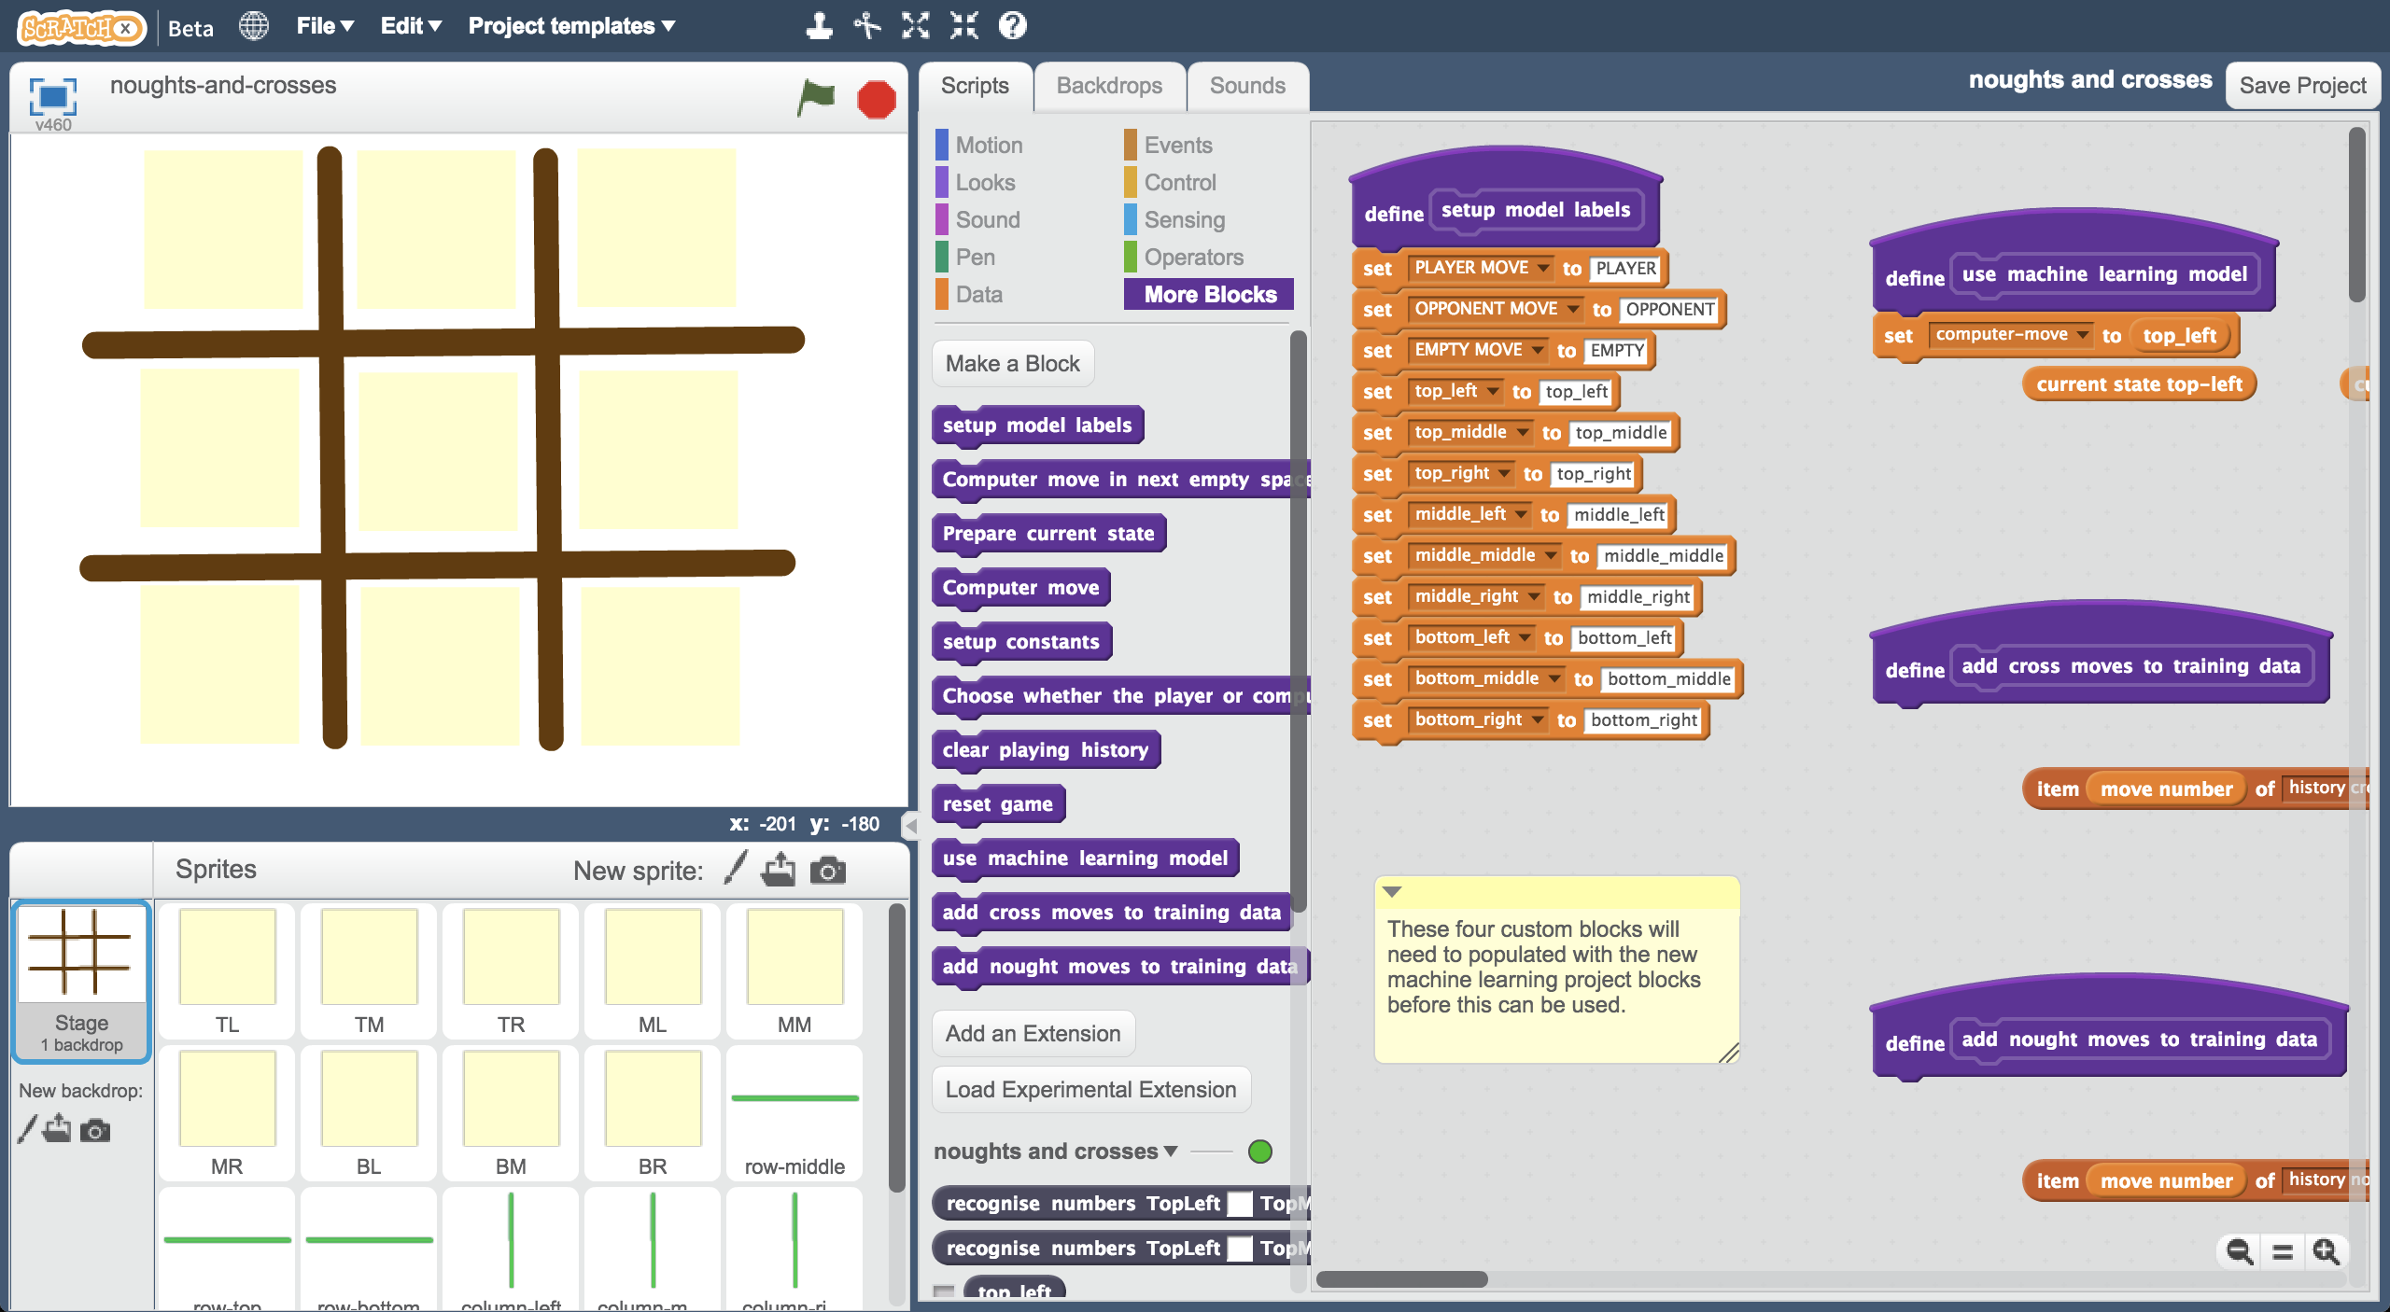

1. 拖曳程式積木更新此段程式碼（如下圖）

Modify the script to use your new project blocks  
*Update it to look like this, by copying in the dark-blue blocks from your project*  
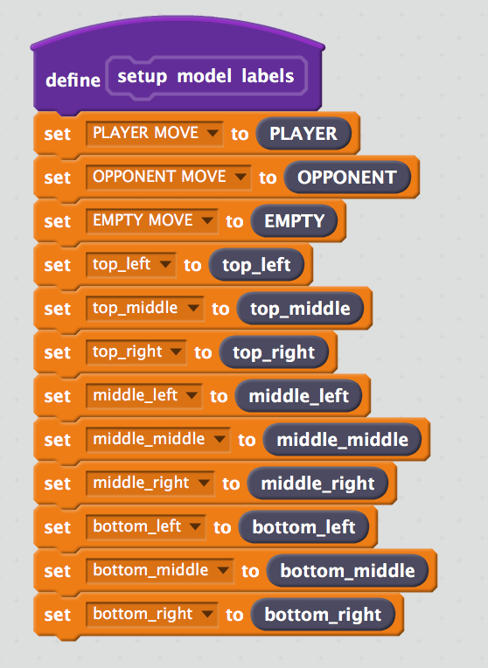

1. 找到pacman-decision為開頭的這段程式碼

*這段程式碼目前還沒有東西，在下個步驟我們會填上他*

Find the “**add cross moves to training data**” script   
*It’s empty – you’ll need to fill it in in the next step.*  
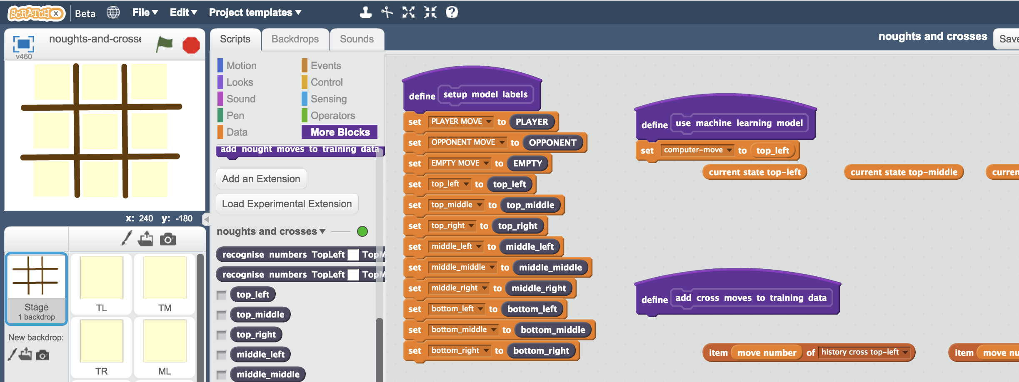

1. 加入“**add training data**”積木

*有兩個積木開頭都是add training data*，選擇第二個（結尾是一個label輸入格）

Add the “**add training data**” block  
*There are two that start with “add training data” – you want the second one, at the very end of the list of blocks, that ends in a “label” text box*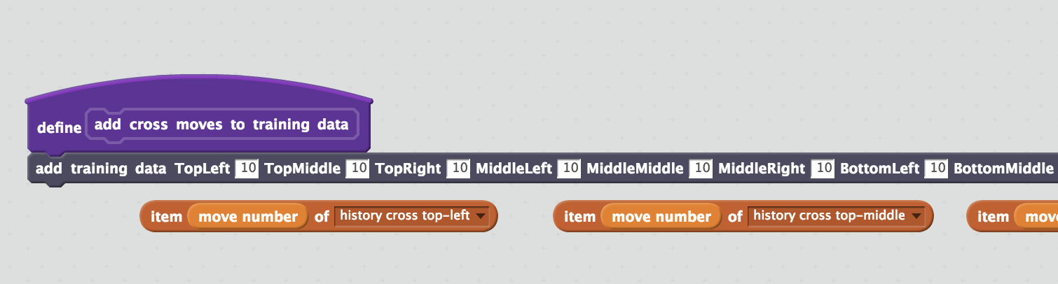

1. 複製**item - move number**積木，將他們依序放入add training data積木的空格中

*如果沒出錯，這些***item - move number**已經幫你複製好了，你只需要拖曳他們填入空格

 Copy the “**item - move number**” blocks into the spaces in the   
“add training data” block  
*The blocks are all ready for you underneath, and they are in the right order.   
You just need to drag them into the spaces*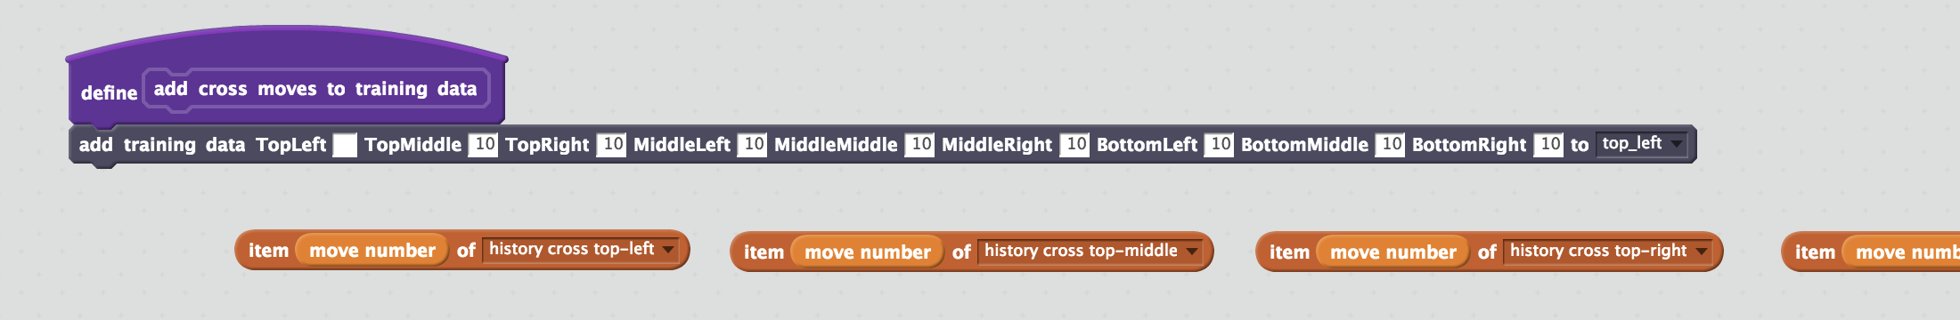  
  
*完成後，你的積木應該看起來像這樣（如下圖）。注意名稱要對應，如TopLeft對應history cross top-left、TopMiddle對應history cross top-middle，最後一格則是history cross choice。*

*這是個複雜的步驟，所以放慢腳步，確定沒放錯！*

*It should look like this when you’re finished. The names should match up: TopLeft goes with “history cross top-left”, TopMiddle goes with “history cross top-middle”, etc.*  
*The last box has the “history cross choice” block.*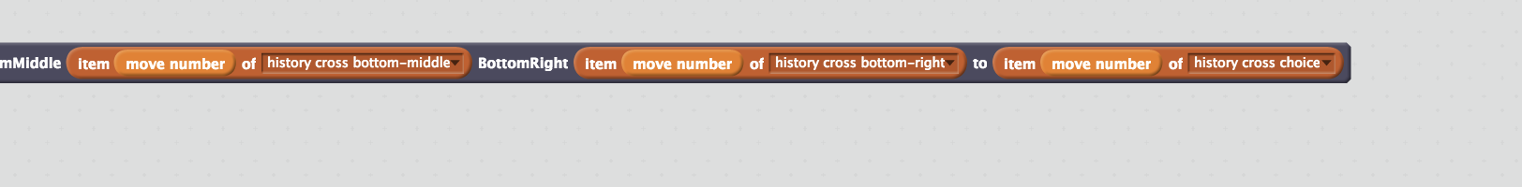  
  
*This is a complicated step – so take your time and do it carefully!*

1. 找到**add nought moves to training data**開頭的積木

Find the “**add nought moves to training data**” script  
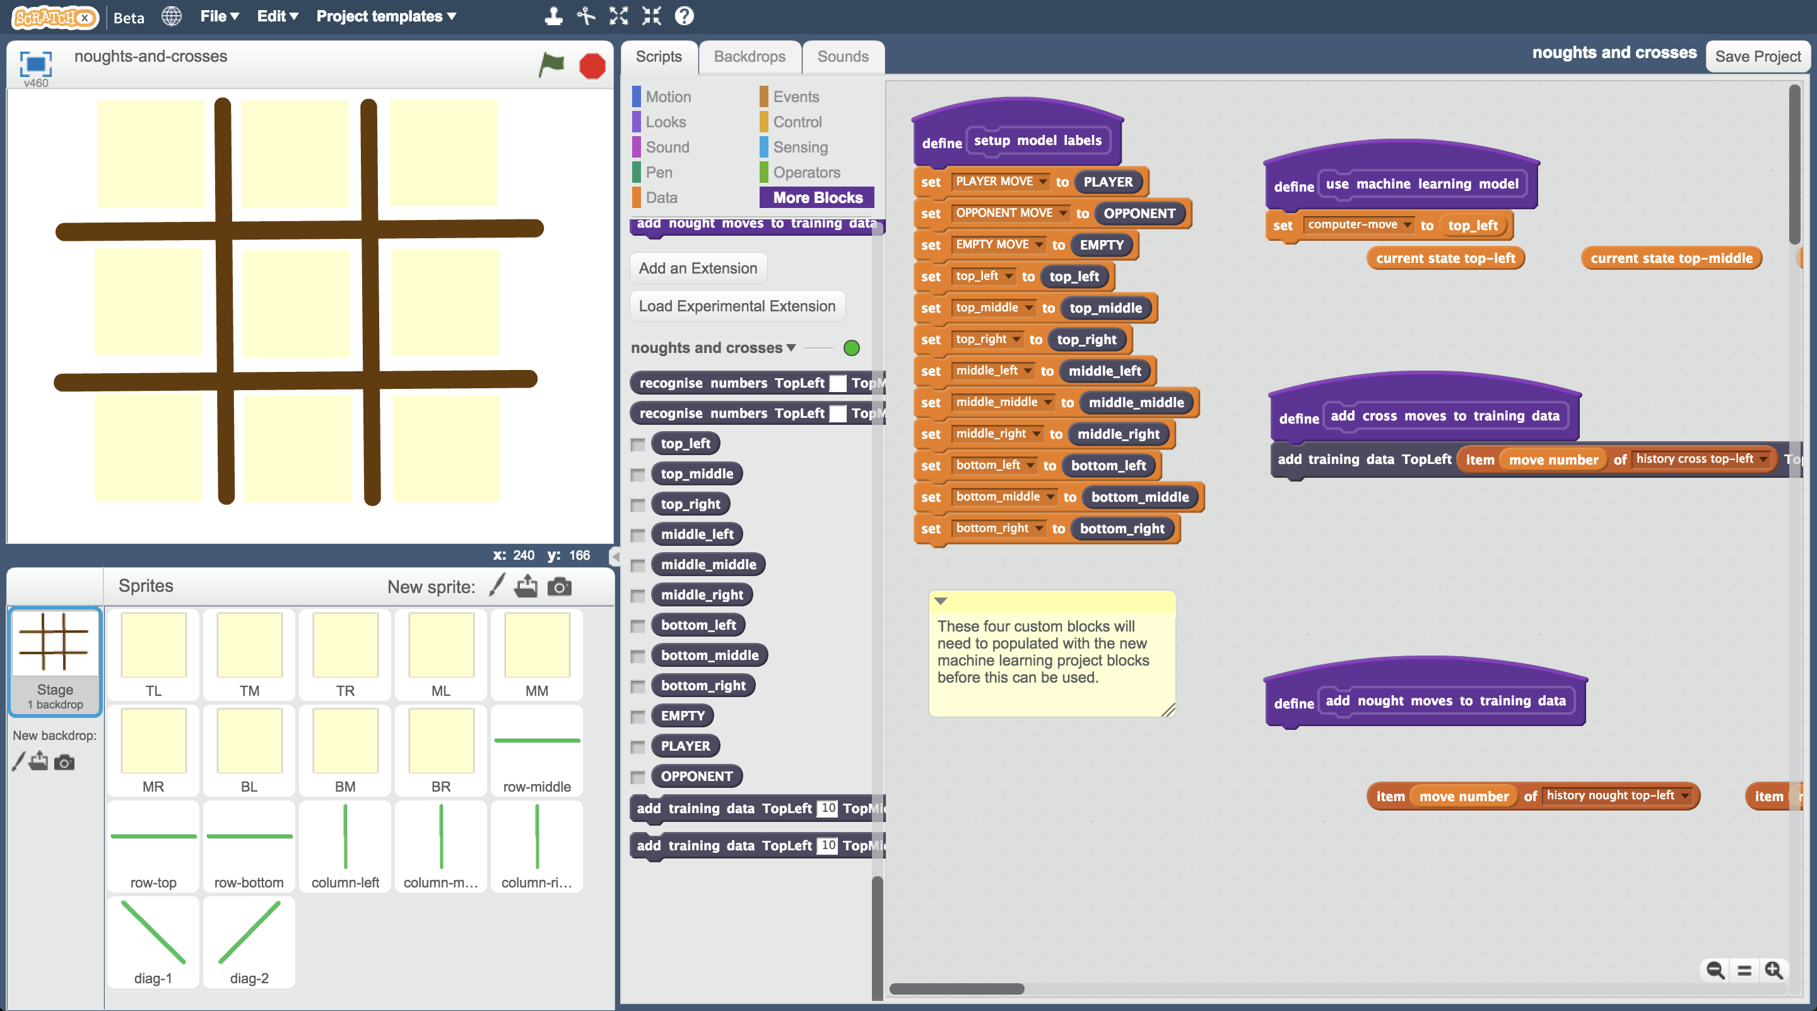

1. 如同前面動作，新增**add training data**積木，複製並拖曳積木到空格中

*注意名稱要互相對應！*

 Add a “**add training data**” block and copy the move blocks into it in the same way as you did with the cross moves  
*Remember to make sure that names in each block match the label to the left on the blue block. e.g. TopLeft goes with “history nought top-left”.*

1. 存檔

*點選檔案，再點選另存專案*

Save your project  
*Click* ***File*** *->* ***Save Project***

1. 點擊綠旗，跟電腦對抗

Play one game against the computer  
*Click on the* ***Green Flag*** *as you did before.   
Play in full-screen mode so you accidentally move sprites.*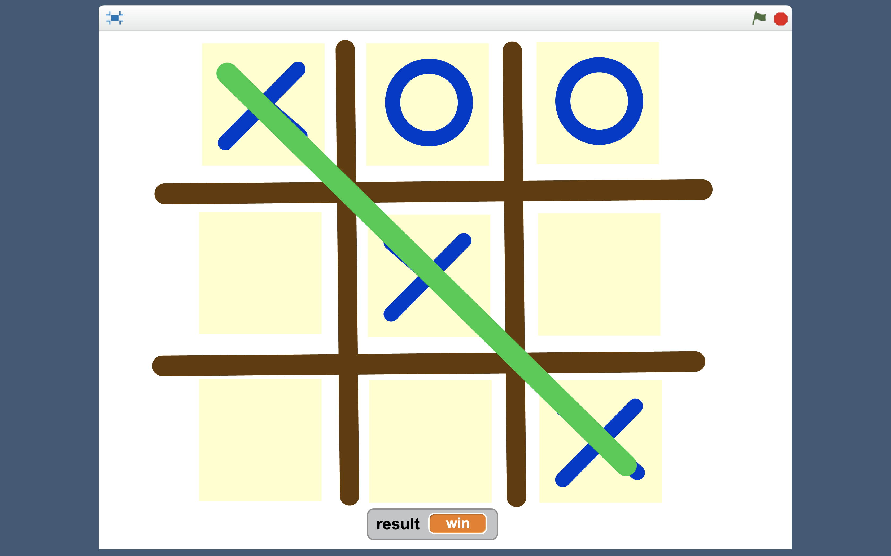

1. 回到訓練視窗，但不要關閉Scratch視窗

點選“**< Back to project**”按鈕，再點選“**Train**”

Go back to the training page  
*Leaving the Scratch window open, go back to the training tool window.   
Click the “****< Back to project****” link and then click “****Train****”  
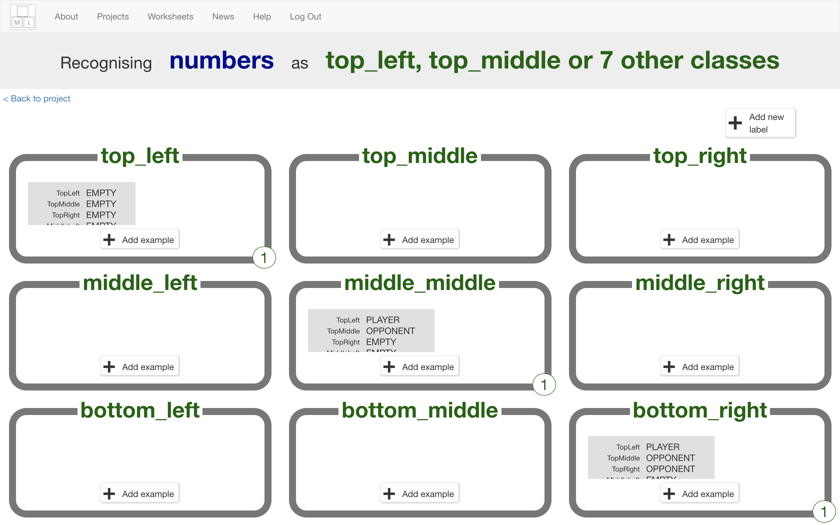*

1. 看看目前的訓練狀況

每一筆記錄都是贏家採取的動作，紀錄中的細節是當時的遊戲狀態

Look at your training so far  
*Each item is a move made by the winning player.   
The details in each item describe the state of the board at the time the winning player made that move.*

1. 回到Scratch視窗

Go back to Scratch window

1. 再玩幾場遊戲，因為我們需要很多範例來訓練電腦

*當你覺得蒐集夠多範例時，回到訓練視窗*

Play several more games – you want lots of training examples to teach the computer how to play the game  
*When you think you’ve got examples of lots of different types of games, go back to the training tool window*

1. 點選“**< Back to project**”按鈕，點選**Learn & Test**

Click the “**< Back to project**” link. Click the “**Learn & Test**” button.

1. 如果畫面出現**Train new machine learning model**，則跳至步驟47，否則繼續步驟44

If there is a “**Train new machine learning model**” button you can go to step **47**. Otherwise, carry on to step **44**.

1. 你的範例數量還不夠多

*為了讓電腦知道什麼時候是在某一位置採取行動的好時機，每個位置需要至少五個範例（而且要結果是獲勝的範例）*

*頁面會顯示目前你有多少範例，這些資訊可以協助你知道哪些位置需要更多範例*

You don’t have enough examples to train the computer yet  
*For the computer to know when it is a good idea to choose any space on the board, you need at least 5 examples of where you chose that space and ended up winning.   
This page shows you how many examples you have so far. Look to see which one(s) you need more examples for.   
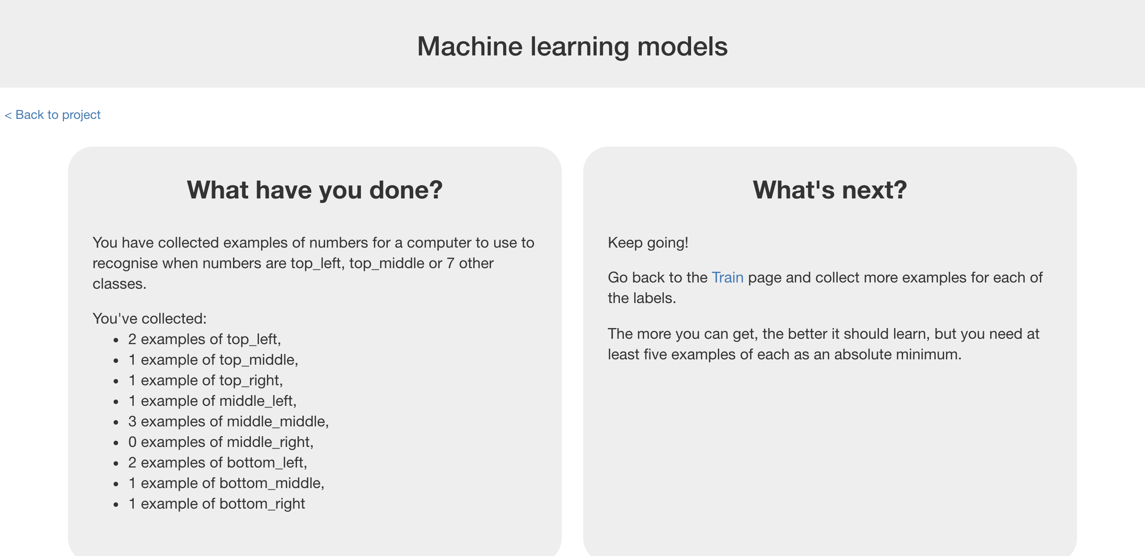*

1. 保持這個網頁開啟，回到Scratch視窗

Leave the “**Learn & Test**” window open.   
Go back to the **Scratch** window.

1. 玩更多場遊戲

*第一步試著從不同位置開始，或者從需要更多範例的位置開始遊戲*

Play more games.   
*Try starting from a different position to get a variety of examples.   
Try starting from positions that you know you need more examples of.*

1. 當你覺得每個位置都已有至少五個範例的時候，回到訓練視窗並重整頁面

*如果還是沒有Train new machine learning model按鈕的話，你需要回到步驟44繼續蒐集範例*

When you think you’ve got at least 5 examples of each space, go back to the “**Learn & Test**” window and **refresh** the page.   
*If there is still no “Train new machine learning model” button, you need to go back to step 44 and try again.*

1. 點選**Train new machine learning model**按鈕

Click the “**Train new machine learning model**” button 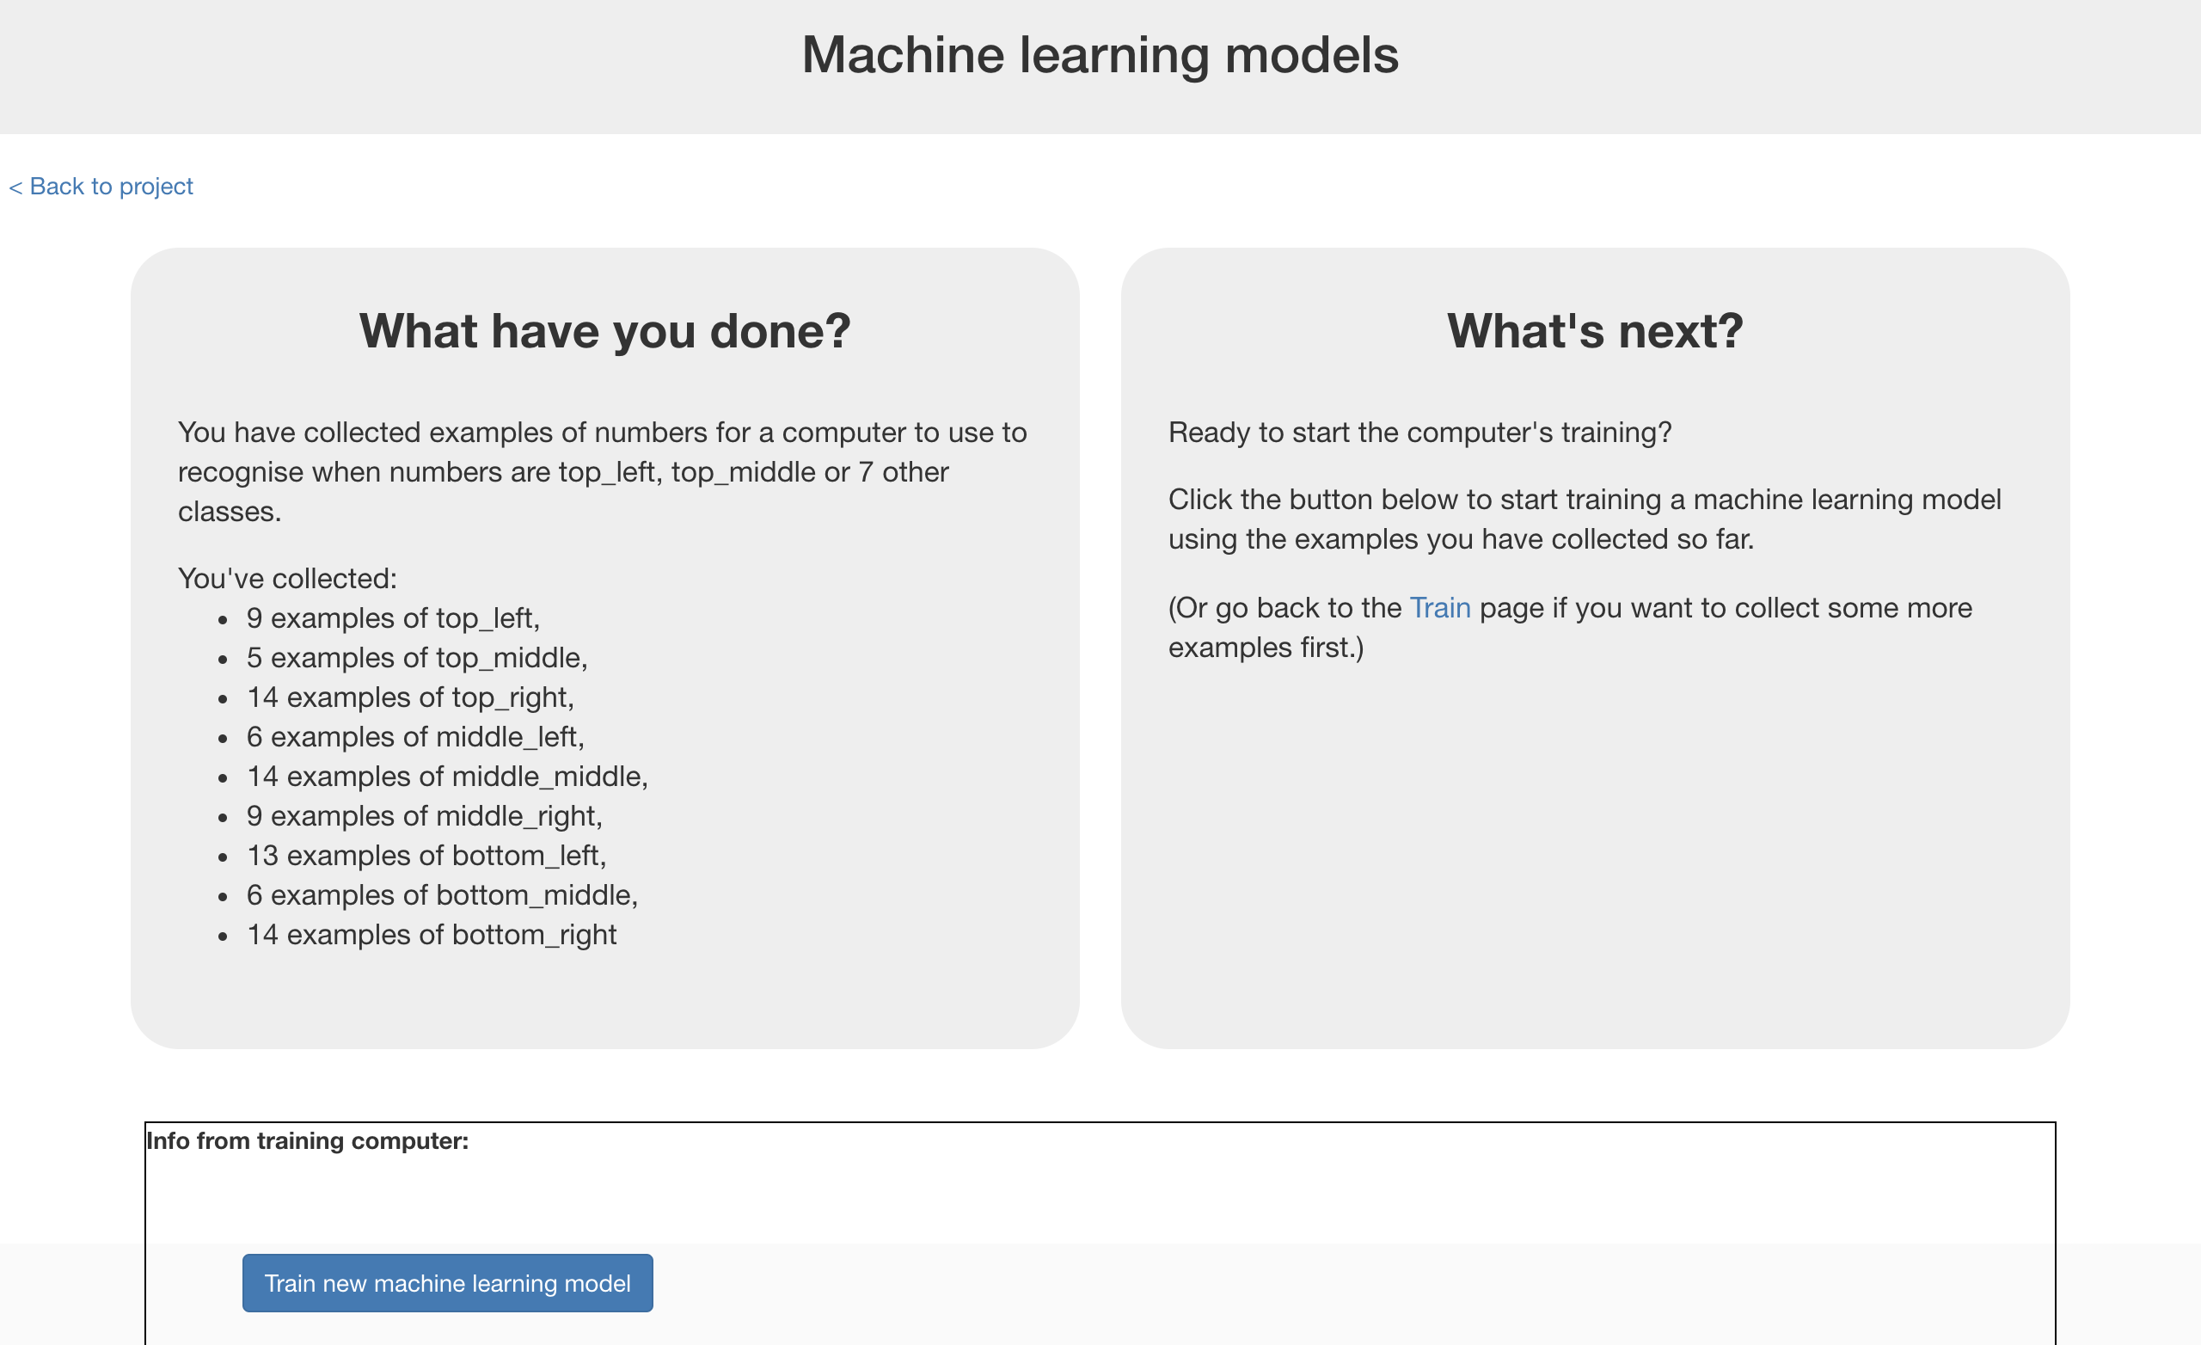

**到目前為止，你完成了什麼？**

**What have you done so far?**

你正在訓練電腦玩圈叉遊戲。

You’re teaching a computer to play noughts and crosses.

你更新了Scratch的圈叉遊戲，紀錄你的遊戲過程，並且利用這些範例來訓練一個機器學習模型。

So far, you’ve updated a Scratch noughts and crosses game so that it can collect examples of how you play and add them to a set of examples. And you’ve used those examples to train a machine learning “model”.

接下來，我們要用模型讓電腦學習決定下個動作，而不再每次都是從空白位置開始。

The next step is to use that model to let the computer decide what move to make – instead of just going for the next empty space every time.

1. 回到Scratch視窗

Go back to the Scratch window

1. 找到**use machine learning model**開頭的積木

Find the “**use machine learning model**” script  
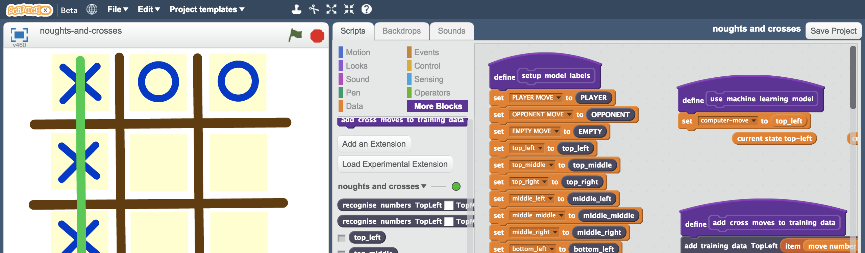

1. 將top_left積木換成**recognise numbers … label**

Replace the top_left block with “**recognise numbers … label**”  
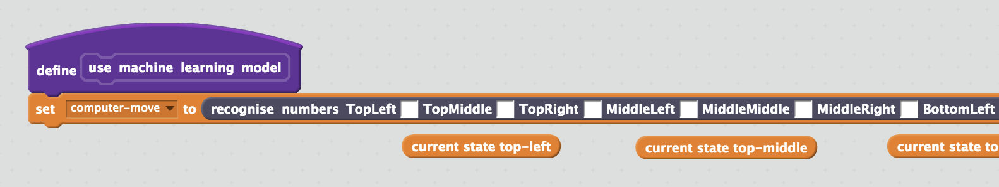

1. 複製橘色積木並拖曳至空格，如同前面的動作一般

 Copy the orange blocks underneath into the spaces in the “recognise numbers” block, similar to what you did before

1. 存檔

*點選檔案，再點選另存專案*

Save your project  
*Click* ***File*** *->* ***Save Project***

1. 點擊綠旗，開始遊戲

*避免每次遊戲過程都是一樣的，試試不同的位置，如此範例多樣性比較大*

Play against the computer by clicking on the **Green Flag**  
*Use full-screen to avoid moving sprites accidentally.  
Avoid playing the same game over and over again. Choose different spaces to give the computer a variety of examples of how to play.*

1. 當你開始覺得遊戲過程都一樣時，回到訓練視窗

點選***Train a new machine learning model***按鈕

When it feels like you’re playing the same games over and over, go back to the “Learn & Test” screen, and use the new training examples  
*Click the “****Train a new machine learning model****” button again*  
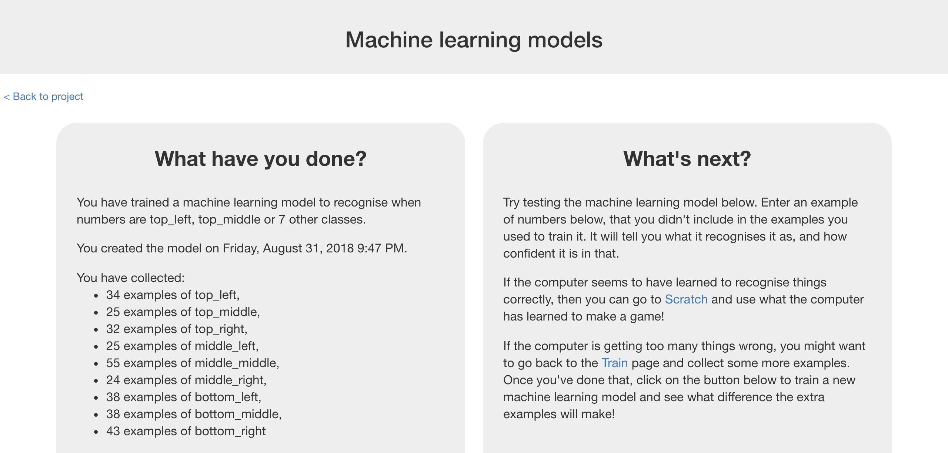

1. 回到Scratch視窗繼續遊戲

一但你覺得遊戲過程開始單調，就再次點選*Train new machine learning mode*按鈕，重複幾次直到模型變好

Go back to the Scratch window and play more games  
*Once you’re struggling to come up with new games, click the “Train new machine learning model” button again.   
Repeat this a few times until your model starts getting good.*

**你完成些什麼？**

**What have you done?**

你訓練了電腦玩圈叉遊戲。

You’ve trained a computer to play noughts and crosses.

你並沒有告訴電腦規則、沒有告訴電腦勝利條件，也沒有告訴電腦行、列、對角線的差別（這些Scratch遊戲裡有，但不算告訴電腦，因為並沒有用在訓練模型裡）

You didn’t have to describe the rules to the computer.

You didn’t tell it that it should try to get three noughts in a row.

You didn’t describe the difference between rows, columns or diagonals.

(The rules are in the Scratch game, but that doesn’t count – that wasn’t used in the machine learning model).

相反地，你蒐集了勝利場次的遊戲過程，將這些當作範例來訓練電腦

Instead, you showed it how you play, by collecting examples of decisions that you made when you win.

當採取了一個決定而最後勝利時，這個決定會被加入訓練資料中，這樣在未來電腦就會更有信心採取同樣的決定。

When it makes decisions that leads to it winning, this is added to its training data, so it can be even more confident in that approach in future.

這被稱作強化學習（reinforcement learning），因為當採取了某個有益於最後結果的動作，你會透過獎勵來『強化』它

This is called “reinforcement learning” because when it does something good you are “reinforcing” this by rewarding it.

**小技巧**

**Tips**

**別心軟！**

**Don’t be kind!**

你可能會在跟電腦對戰時心軟，特別是電腦才剛開始學習，玩得非常差的時候。

You might be tempted to go easy on the computer when you’re playing against it, particularly when it’s just starting to learn and is playing very badly.

舉例來說，可能現在你已經有兩個X在同一線上，而且旁邊是空的，這代表你快贏了！但你可能會覺得愧疚而把X畫在其他格子裡

For example, you might have two crosses-in-a-row next to a blank space and could win. But instead, you might feel sorry for it doing badly and put a cross somewhere else instead to give it a chance.

別這麼做！

Don’t.

電腦是從你的遊戲過程裡學習的，如果你不在可以獲勝時就結束遊戲，電腦就會學到他應該也這麼做。

It is learning from the way that you play. If you don’t complete a three-in-a-row when you can, you will be teaching it that it should do that.

如果你想要電腦更快學好，**就盡全力玩遊戲**！

If you want it to get better quickly, **play as well as you can**.

**範例多樣化**

**Mix things up with your examples**

試著蒐集不同的範例

Try to come up with lots of different types of examples.

舉例來說，每局遊戲都從不同的位置開始

For example, start from a different position on the board on every turn.

**你知道嗎？**

**Did you know?**

人們已經透過訓練電腦玩圈叉遊戲來研究機器學習幾十年了！

People have been learning about machine learning by training a computer to play noughts and crosses for decades!

一個著名的例子是**Donald Michie**：一位英國人工智慧研究員，二戰期間，他在Bletchley Park擔任破譯員。

One famous example was **Donald Michie** – a British artificial intelligence researcher. During World War II, Michie worked at Bletchley Park as a code breaker.

1960年，他開發了**MENACE** (Machine Educable Noughts And Crosses Engine)，這是第一個學習玩圈叉遊戲的專案

In 1960, he developed “**MENACE**” – the Machine Educable Noughts And Crosses Engine. This was one of the first programs able to learn how to play noughts and crosses perfectly.

當時Michie沒有電腦可以用，因此他使用304個火柴盒小汽車和彩色玻璃珠來建造MENACE。

As he didn’t have a computer he could use, Michie built MENACE using 304 matchboxes and coloured glass beads.

每一個火柴盒小汽車代表一個遊戲板狀態，就像你蒐集的範例。

Each matchbox represented a possible state of the board – like the examples that you’ve been collecting in your training data.

他將彩色玻璃珠放入盒中，用以代表這個決定有多常會導向勝利的結果。盒子中的玻璃珠數量就如同你的訓練資料方框中出現的範例次數。

He put beads in the matchboxes to show how often a choice led to a win – the number of beads in the matchbox was like the number of times an example shows up in one of the buckets you created for your training data.

